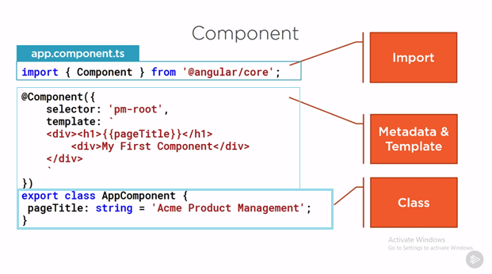

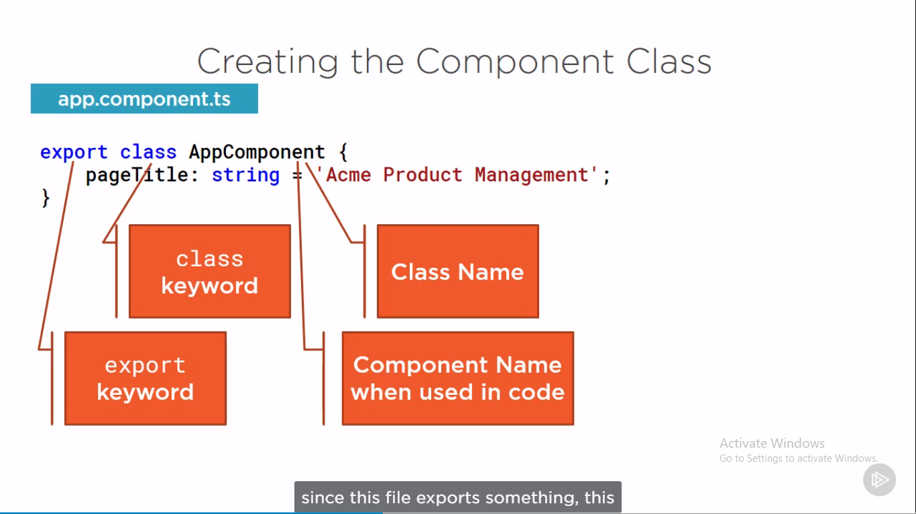

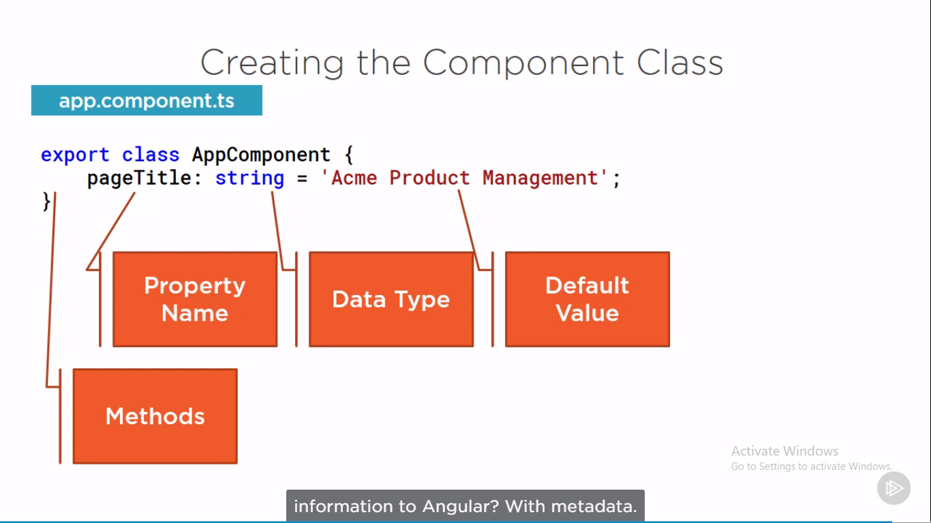

Method is not yet defined

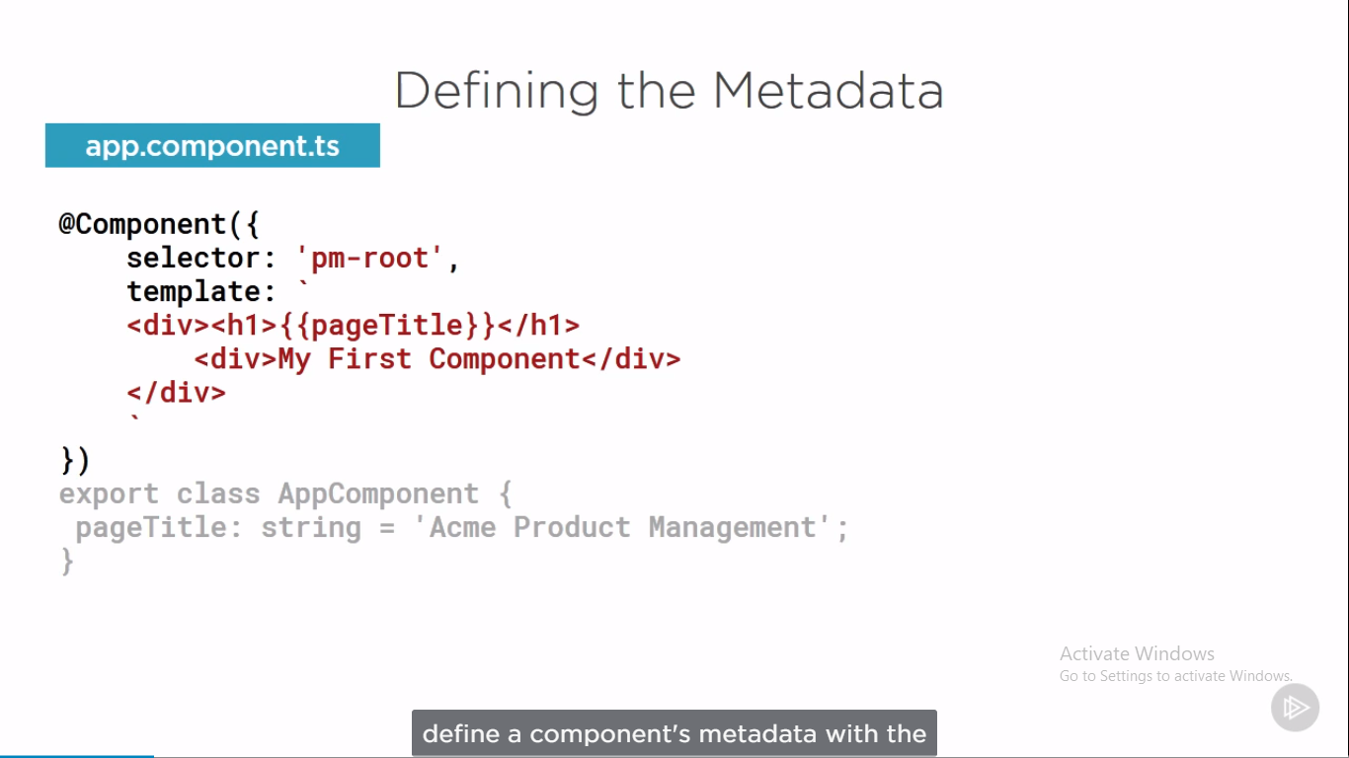

A class became an angular component when we give it **component metadata (Provide @Component).** Angular needs that metadata to understand how to instantiate the component, construct the view and interact with the component. We define a component metadata with the Angular component function(@Component). In type script we attach that function to the class as a decorator.

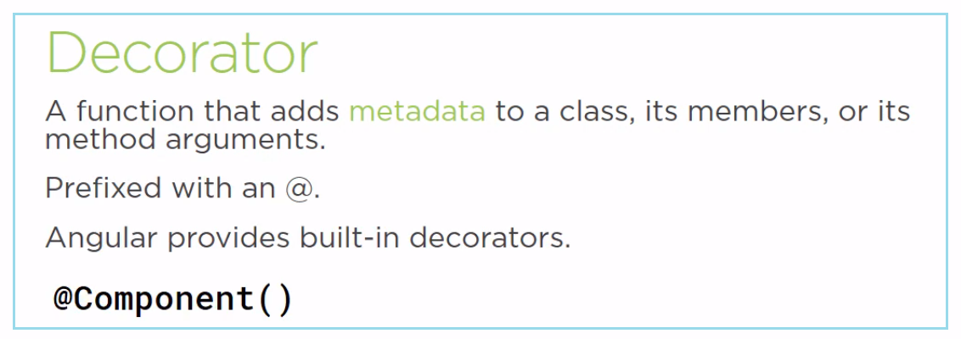

A decorator is a function that adds metadata to a class, its members or its method arguments. A decorator is a JavaScript language feature that is implemented in typescript. The scope of the decorator is limited to the feature that is decorate. A decorator is always prefix with an **@** sign. Angular has several built-in decorators we used to provide additional information to angular. We can also build our own decorators.

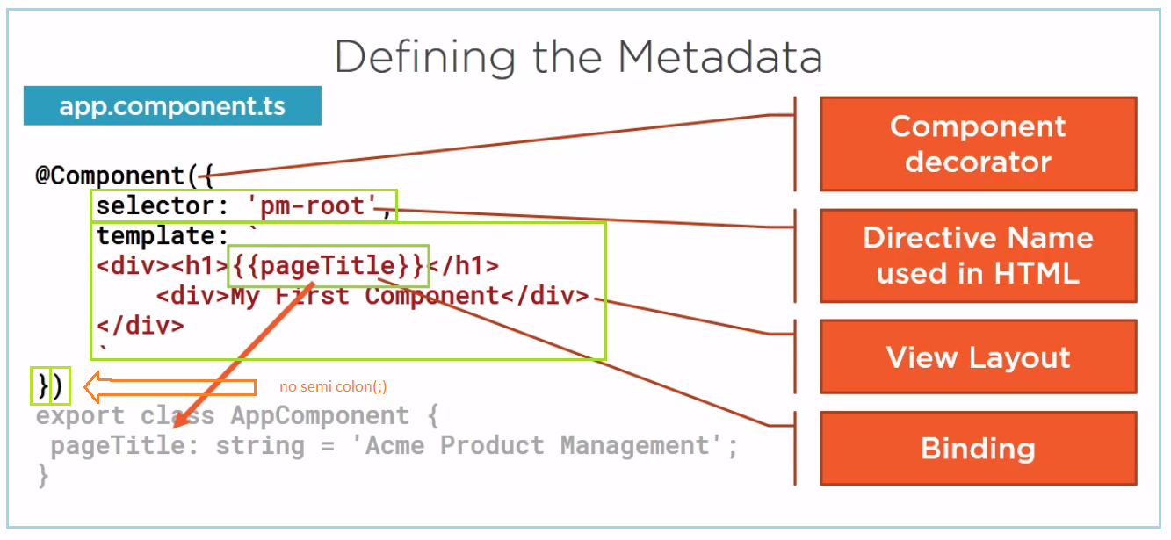

We apply a decorator by positioning it immediately in front of the feature we are decorating. When decorating a class, as in this example, we define the decorator immediately above the class signature. Notice that there is no semicolon here. This syntax is similar to attributes used in other programming languages. We used this @component decorator to identify the class as a component. Since the decorator is a function, we always add parenthesis. We pass an object to the component function as indicated with the curly braces. The object we pass in has many properties. We are only using 2 of them here. If we plan to reference the component in any HTML, we specify a selector. The selector defines the component’s directive name. A directive is simply a custom HTML tag. Whenever this directive is used in the HTML Angular render this component’s template. A component should always have a template. Here we define the layout for the user interface fragment or view managed by this component. The double curly braces indicate data binding. We bind the h1 element value to the pageTitle property of the class. So, when this HTML is rendered, the h1 element displays in ACME product management.

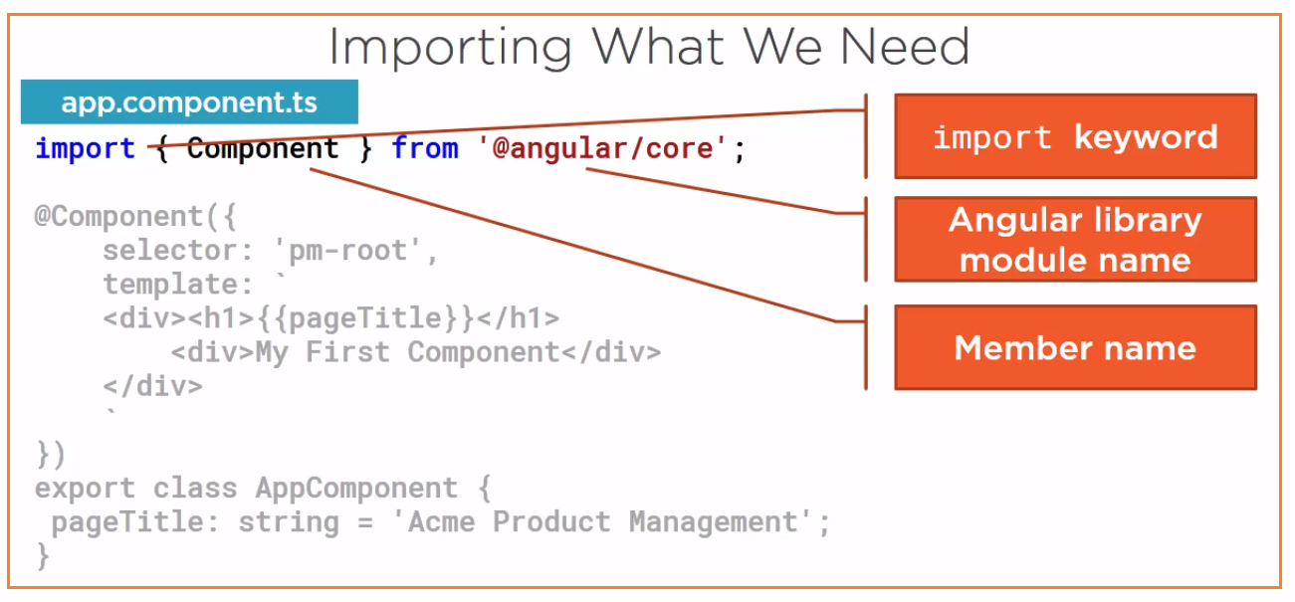

The import statement allows us to use exported members from external ES modules. We use import statement throughout our code to import any third-party library, any of our own modules, or from angular itself. We can import from angular because angular is modular.

Src > app >app.component.ts

This is called root component

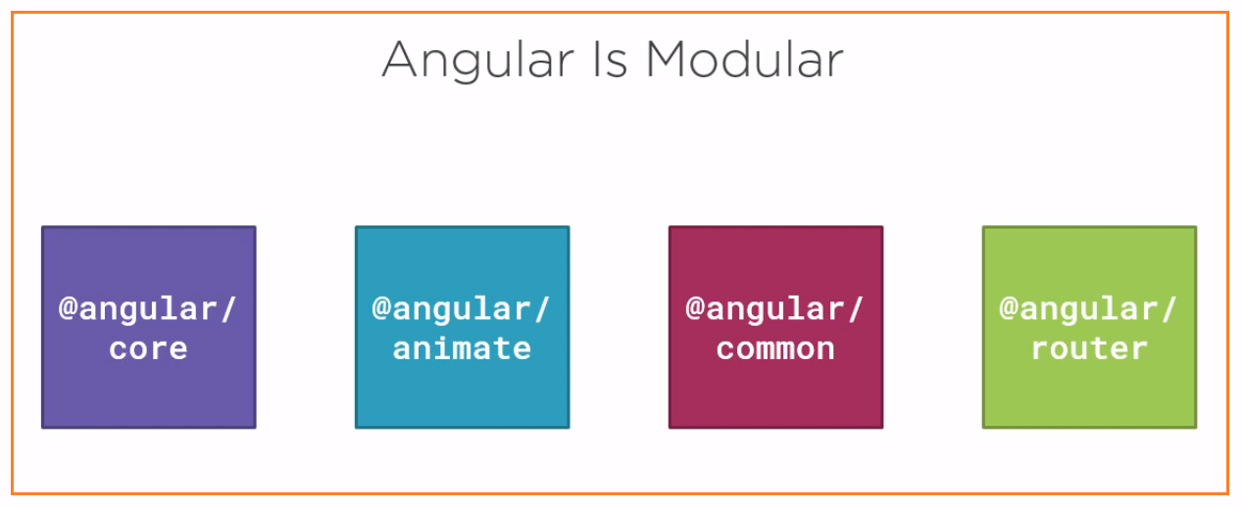

It is collection of library modules. Each library is itself a module made up of several related feature. when we need something from angular, we import it from an angular library module, just like we import from any other external module. In our component code, we use the @Component decorator function from angular to define our class as a component. We need to tell Angular where to define this function, so we added an import statement and import {Component} from ‘@angular/core’;

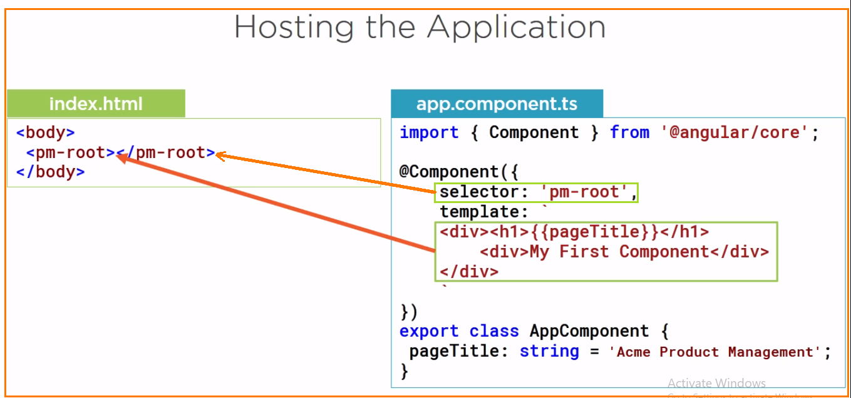

In component, selector is the name of the component when we use as directive in HTML and the template defines the HTML that we want to display. So, in the index.html file we simply add the selector where we want our template displayed.

A directive is basically a custom element. As soon as the loading is completed, the template defined in the component template is inserted between the selector element tags and appears on the page. But how does the angular know about this custom HTML **<pm-root></pm-root>** element?

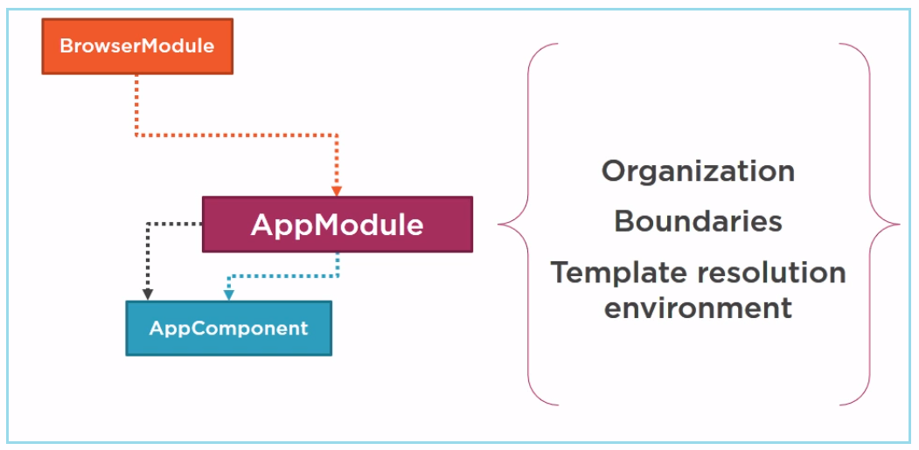

It looks in the angular module. Angular modules help us organize our application into cohesive blocks of functionality and provide boundaries within our application. They also provide a template resolution environment. What does that mean? When the angular compiler sees a directive and a template, it looks to the angular module for the definition. So, we declare the app component in an angular module so the compiler can find it. We also use the module to bootstrap our startup component, which is our AppComponent. And we want our application to work correctly in the browser, so we add angular browser module to our angular module’s imports.

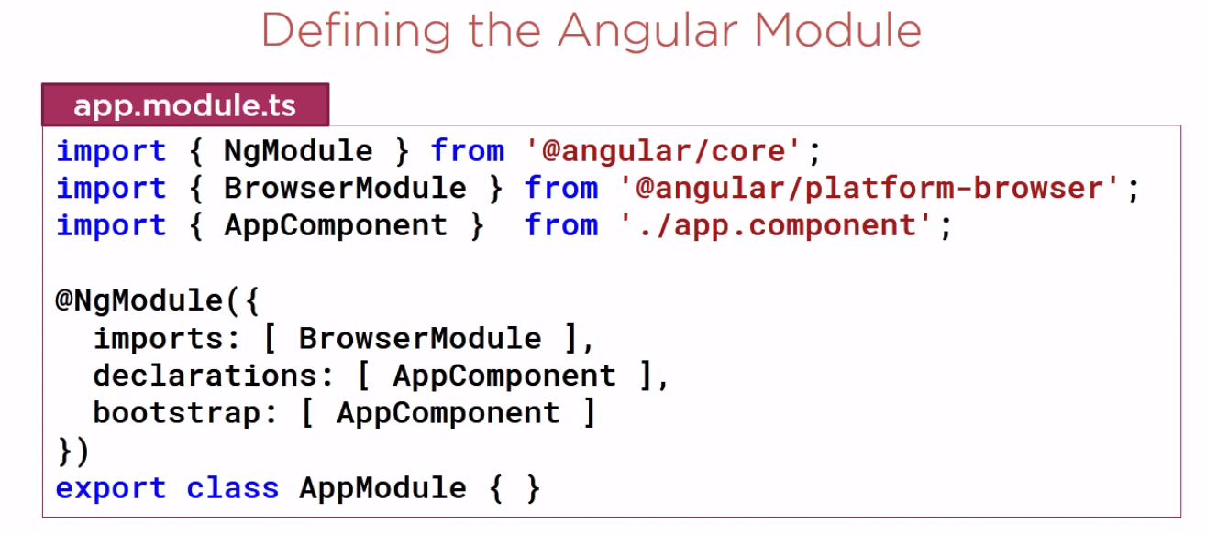

If you want to insert bit of HTML into 1 HTML page define in index.html, In above code, here is our application’s root angular module. As with most everything in Angular, we define an angular module using a class. We identify a class as an angular module by attaching the **@NgModule** decorator and passing in metadata defining the details of this angular module. For the NgModule decorator, the properties are arrays.

In the **declarations array**, we define which of our component belong to this module. By convention, our root application component, AppComponent, belongs to the application’s root angular module, AppModule, so we declare it here. We can add other components here as well.

In the **imports array,** we define the external modules that we want to have available to all of the components that belongs to this angular module. External module could be module provide by angular, a third party, or our own angular modules. Here we import Browsermodule, which every browser application must import. Browser module register import application service provider such as error handling.

The **bootstrap array** defines the starting(startup) component of the application, which is our AppComponent. The startup component should contain the selector we used in the index.html file, which in this case it does.

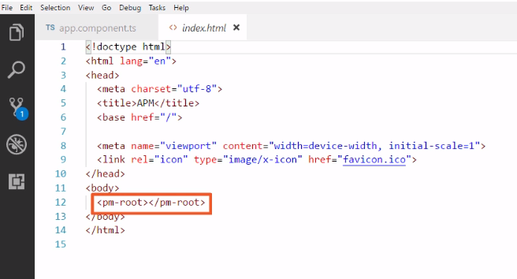

Bootstrapping our app component

Starting with the index.html, To host our application and examine the root angular module that bootstrap our app component. Index.html file is already hosting the app component, and the **app.module.ts** file already bootstraps our app component.

We use the component selector as a directive here within the body element. We can think of directive as simply a custom HTML tag. The directive **<pm-root></pm-root>** is included here

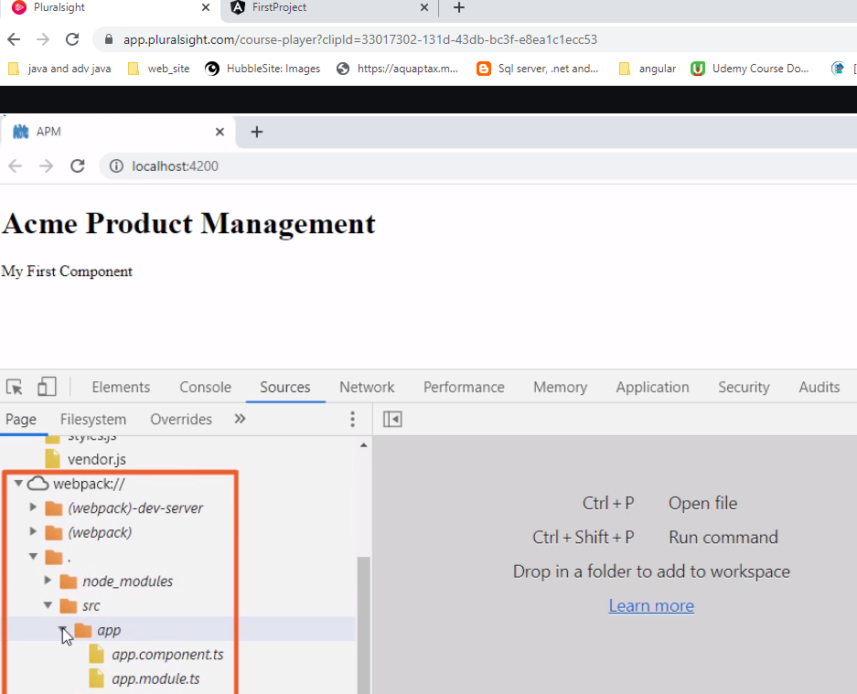

Since angular CLI uses the **webpack,** our typescript file is listed under the webpack node here

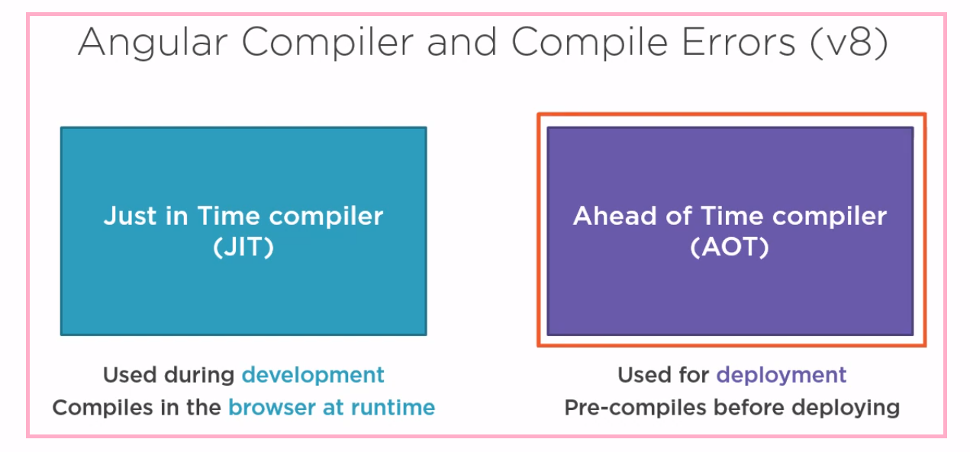

Because browser don’t understand the component and template we build, Angular applications require a compile process to convert our templets and typescript code into JavaScript. Angular has 2 compilers, a just in time (JIT) compiler, which was used during development. It compiles our application in the browser at run time, making it quick and forgiving. And an ahead of time (AOT) compiler which was used for deployment. It compiles the application ahead of time before serving it to the browser, so we don’t need to include the angular compiler and the compiled bundles, which mean smaller bundles, less for the users to download, and faster rendering. Having 2 compilers was sometimes a problem in that our code would work fine when compile with JIT compiler during development, but would fail when compiled with the AOT compiler for production.

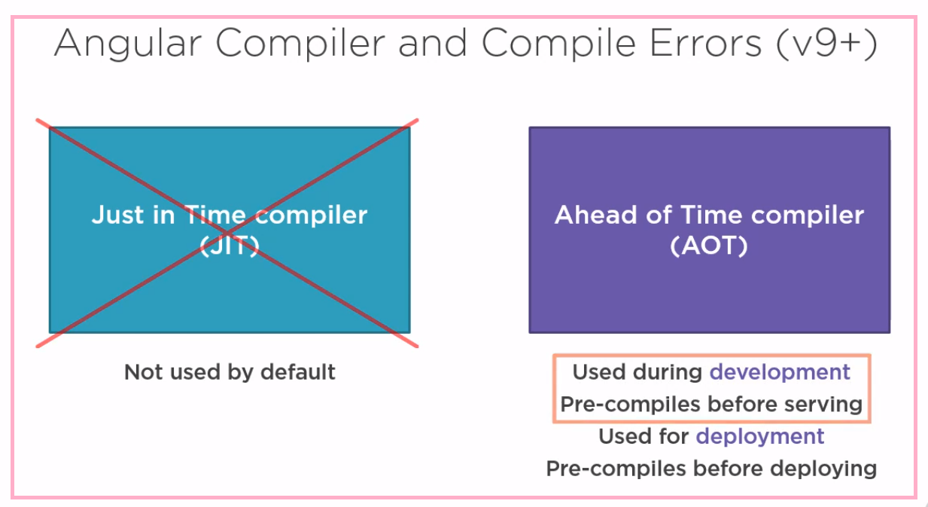

Starting with the angular version 9, the performance of the AOT compiler was improve enough to use it for development as well. It now compiles before serving the application to the browser. Using one compiler for both development and deployment mitigate any issues early and not during final build for production.



However, the AOT compiler comes with some changes in how we see our syntax and compile errors. When we start our application with npm start, Angular compiles then serves the application to the browser.

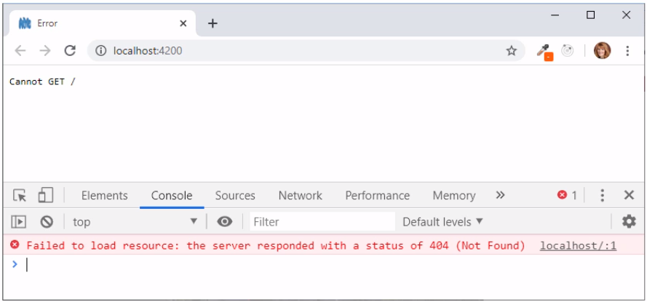

If the application has compilation errors, we may see this in the browser “cannot GET” as well as in red by F12, that’s not very helpful. In this case, this message is telling us that angular could not serve our application to the browser because it could not successfully compile it.

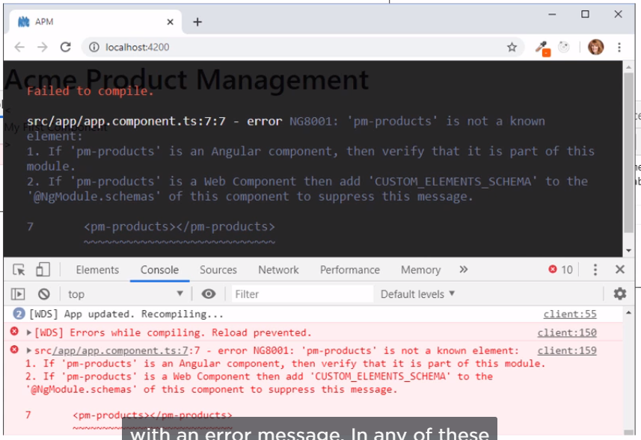

If the application is already running successfully, and then we make a change that cause a compile error, we may see the last successful compile file in the browser, or we may see a black overlay with an error message. In any of these cases, the best course of action opens the vs code terminal window. It will display any or all compile errors.

**Template**

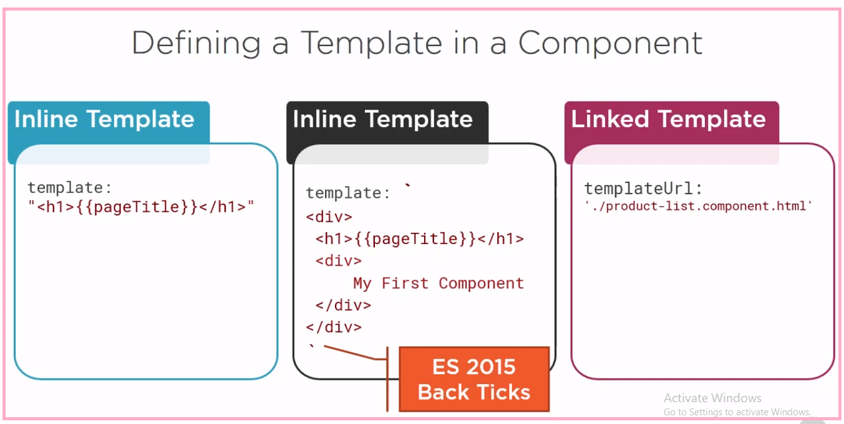

We can use the template property and define an inline template using a simple quoted string with single or double quotes. Or we can define an inline with a multiline string by enclosing a HTML in ES 2015 back ticks. The backticks allow composing a string over several line, making the HTML more readable. There are some advantages to defining an inline template using one of these two technique. The template is directly defining within the component, keeping the view and the code for that view in one file. It is then easy to match up our data binding with the class properties, such as the page title, in this example. However, there are disadvantages as well. When defining the HTML in a string, most development tool don’t provide intelliSence, automating formatting, and syntax checking. In many cases better option is to define a linked template with the HTML in its own file. We can then use the **templateUrl** property in the component metadata to define the URL of our HTML file.

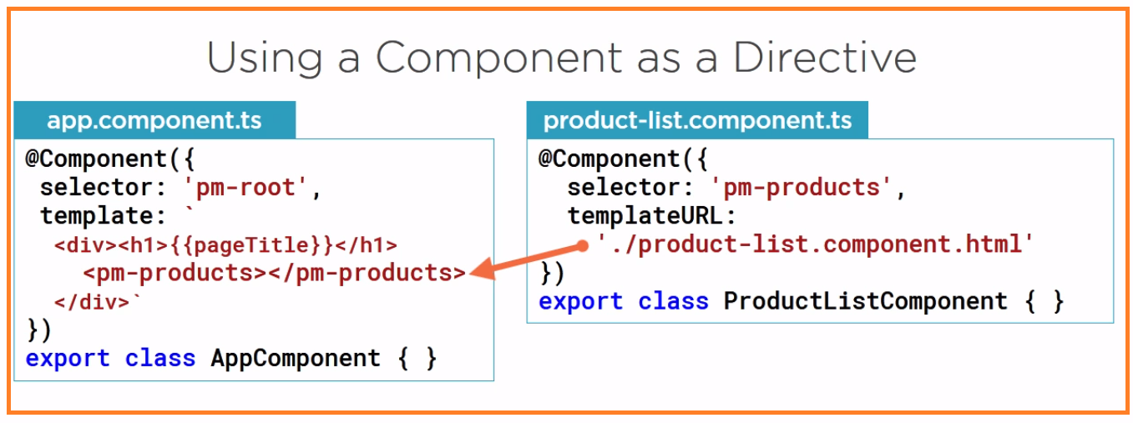

We could have hundreds of components in our application. Every angular application must have at least one Angular module, the Application module, commonly called AppModule. Currently our AppModule declares our root application component, AppComponent. A component must belong to one and only one angular module. Because the AppModule declares the AppComponent, the AppComponent belongs to the AppModule. The AppModule bootstraps the application with the component, so it is the first component that is loaded for our application. Our AppModule also imports the system browser module to pull in the futures it needs to run this application in the browser. So, this is what our AppModule currently looks like. **An angular module defines the boundary or context within which the component resolves this directives and dependencies**. So, when a component contains a directive, Angular looks to the component’s module to determine which directives are visible to that component. What does mean for us? Well, for angular to find the pm-product directive used in the app.component, the product-list.component must also be declared in this angular module. This is the second step when using a component as directive. we need to ensure that the directive is visible to any component that uses it.

**Binding**

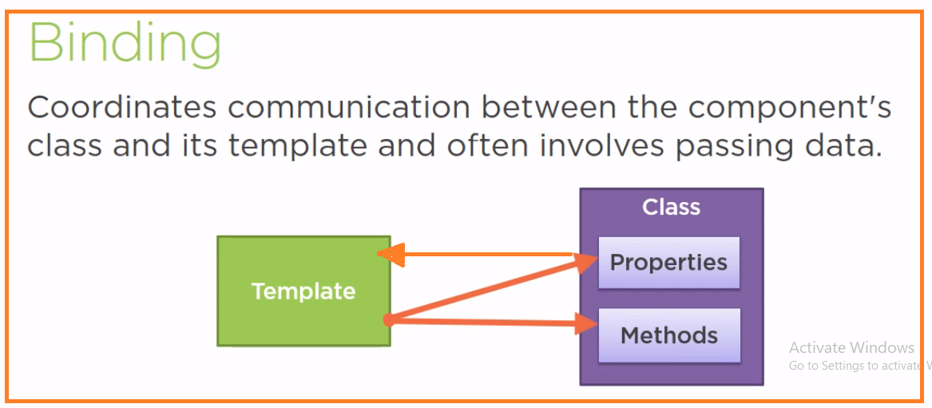

Angular provide several types of binding

1. Interpolation

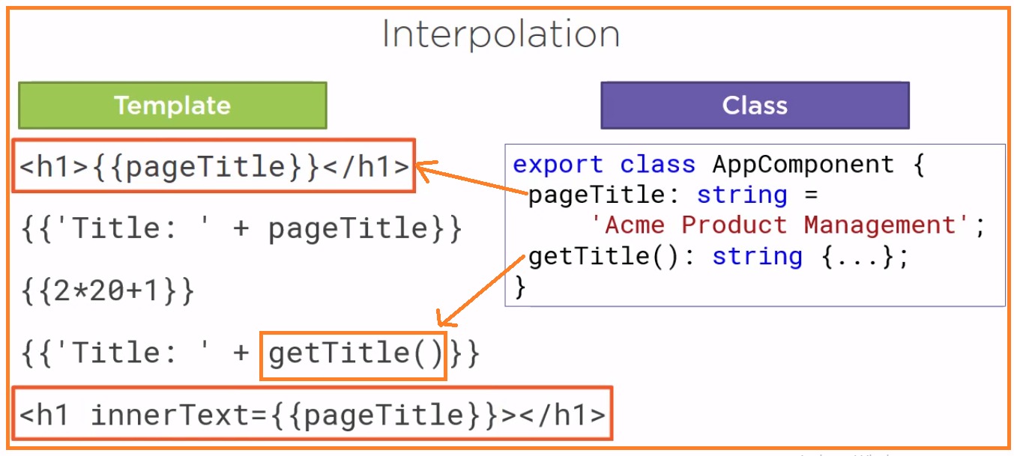

Interpolation is a one-way binding from the class property to the template. It supports much more than simple properties. We can perform operation such as concatenation or simple calculation. We can even call a class method, such as getTitle () shown. The syntax between the interpolation curly braces is called a template expression.

**Directive**

Custom HTML element or attribute used to power up and extend our HTML. We can build our own custom directives or use Angular’s built in directive.

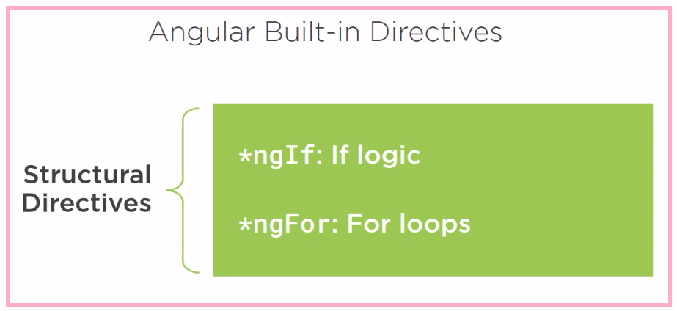

**A structural directive modifies the structure or layout of the view by adding removing or manipulating element and their children.** They help us to power up our HTML with if logic and for loops. Notice the asterisk in front of directive name. that mark the directive as a structural directive.

How our application finds ngIf or ngFor? Browser module exposes the ngIf and ngFor directives. So, any component declared by the AppModule can use the ngIf and ngFor directives.

In typescript, we use **any** as the datatype any time we don’t know don’t care what the specific datatype is.

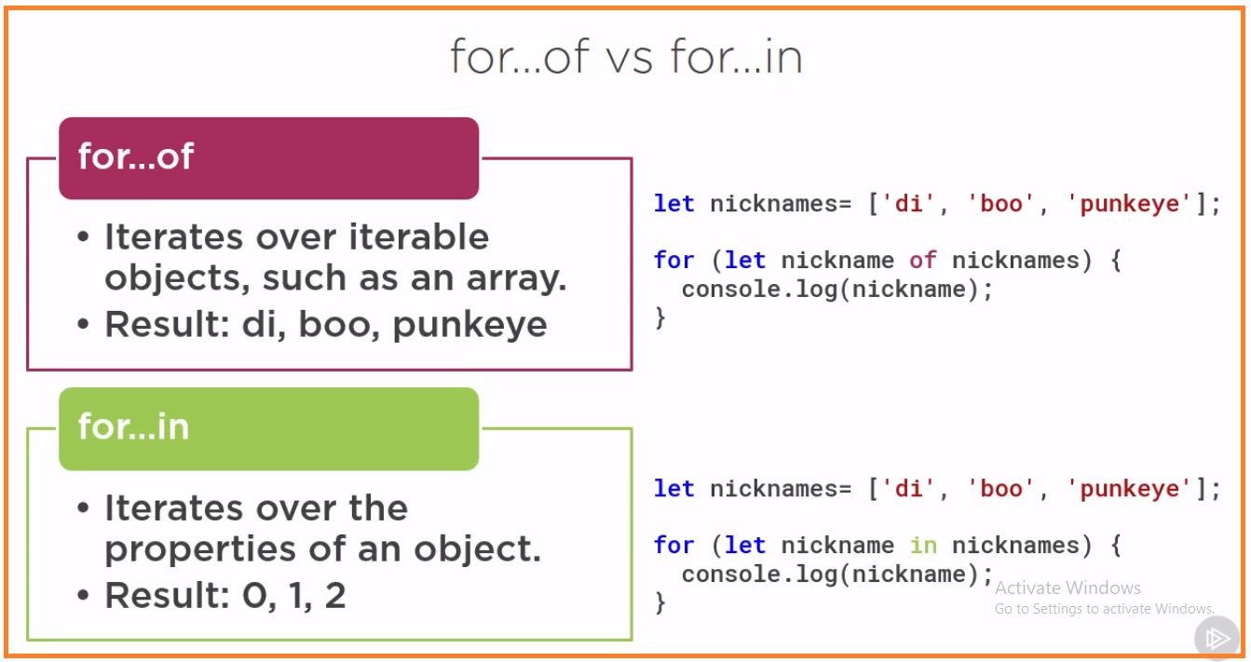

for…of is like for each loop

**Property binding**

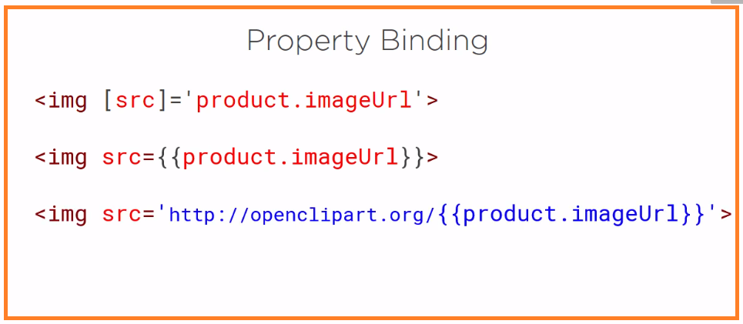

**Event binding**

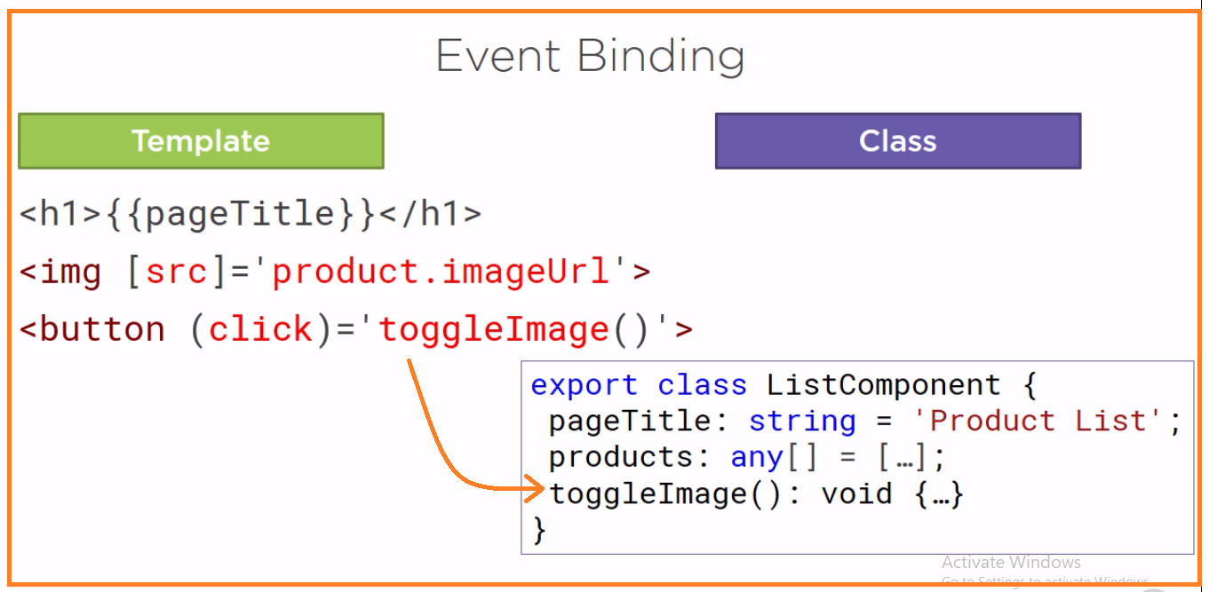

**Two-way-binding**

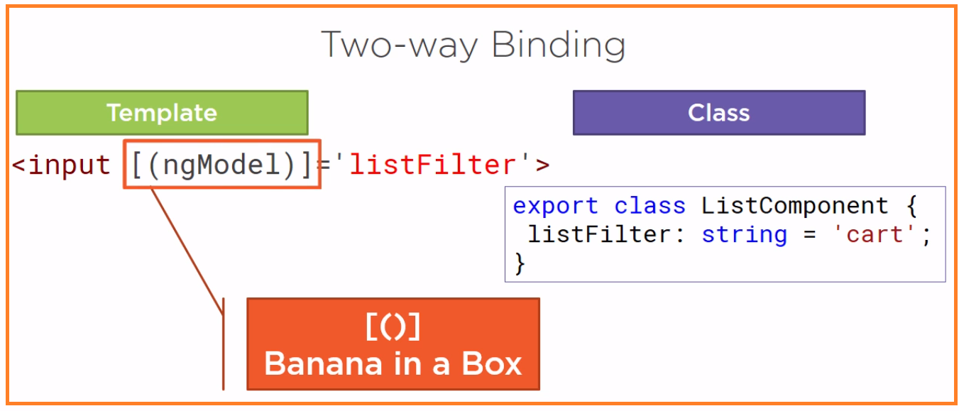

When working with user entry HTML element, such as input element, we often want to display a component class property in the template and update that property when the user make a changes. This process requires two-way binding. To specify two-way binding in Angular, we use the ngModel directive. we enclose ngModel in square brackets to indicate property binding from the class property to the input element, and paranthesis to indicate event binding to send a notification of the user-entered data back to the class property. We assign the directivce to a template expression. To help us remember which order to put the two sets of brackets, visualize a banana in box. Square brackets for the box on the outside and paranthesis for the banana on the inside. So now we have another angular directive that we can use. Every time we want to use an angular directive in a template, we need to consider how to make that directive visible to the component associated with that template. Recall that an angular module defines the boundary or context within which the component resolves its directives and depedencies.

**Transforming data with pipe**

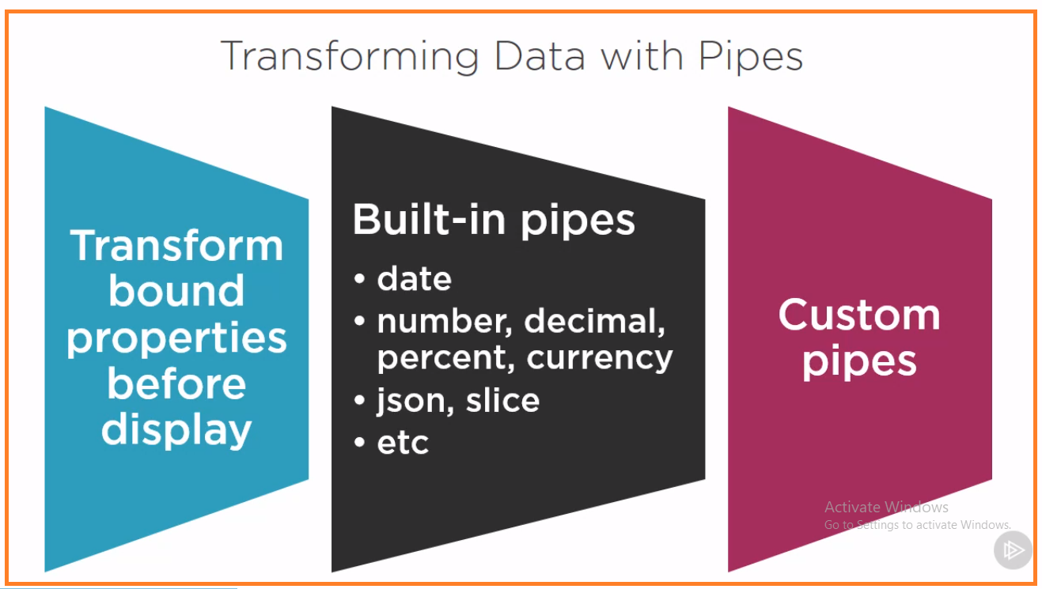

With angular’s data binding, displaying data is easy, just bind an element property to a class proprety and we’re done. Well, not always. Sometimes the data is not in a formate appropriate for a display. That’s where pipes come in handy. Pipes transform bound properties before they are displayed so we can altere the property values to make them more user friendly or more locale appropriate.

Angular provides some built-in pipes for formatting values such as date, number, decimal, percent, currency, uppercase, lowercase and so on. Angular also provide few pipes for working with objects, such as the json pipe to display the content of an object as a json string, which is helpful when debugging, and a slice pipe, which select a specific subset of elements from a list. We can also build our own custom pipes.

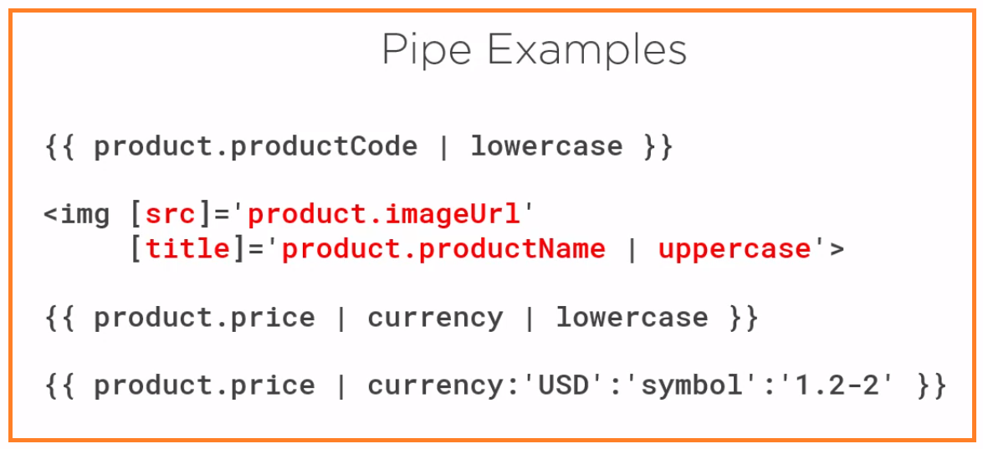

The currency pipe has 3 parameters, the desired currency code, a string define how to show the currency symbol, and digit info. The digit info consis of minimum no of integer digits, the minimium number of fracrional digit(2) and maximum no of fractional digit(2) the value here of 1.2-2 means atlest 1 digit to the left of the decimal and atleast 2 digits to the right to the decimal and no more than 2 digit to the right of the decimal effectively defining 2 decimal places.

**Data binding (Summary)**

Data binding make it easy to display class property from our component and set DOM element properties to our class property values to better control the view. And the component can listen for events from the DOM to respond as needed for an interactive user experience.

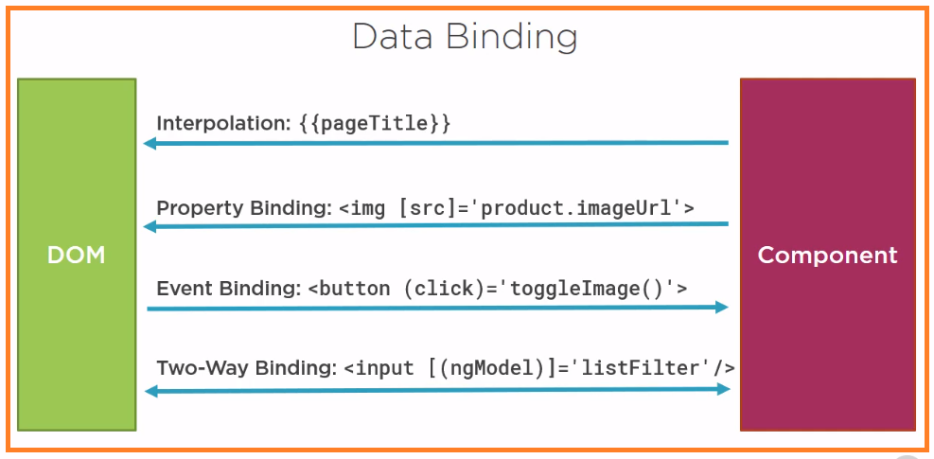

There are four basic type of binding in angular

1. Interpolation insert interpolated strings into the text between HTML elements or assign element properties. Be sure to wrap the template expression in curly braces and no quotes.
2. Property binding sets an element’s property to the value of a template expression. The binding target species the property of the element and must be enclosed in square brackets. The binding source specifies the template expression and must be enclosed in quotes.
3. Event binding listens for events and execute a template statement when the event occurs. The target events specify an event name and must be enclosed in parenthesis. The template statements often define the name of the method to call when the event occur and must be enclosed in quotes.
4. Two-way binding displays a component class property and update the property when the user makes the changes

**More on Component**

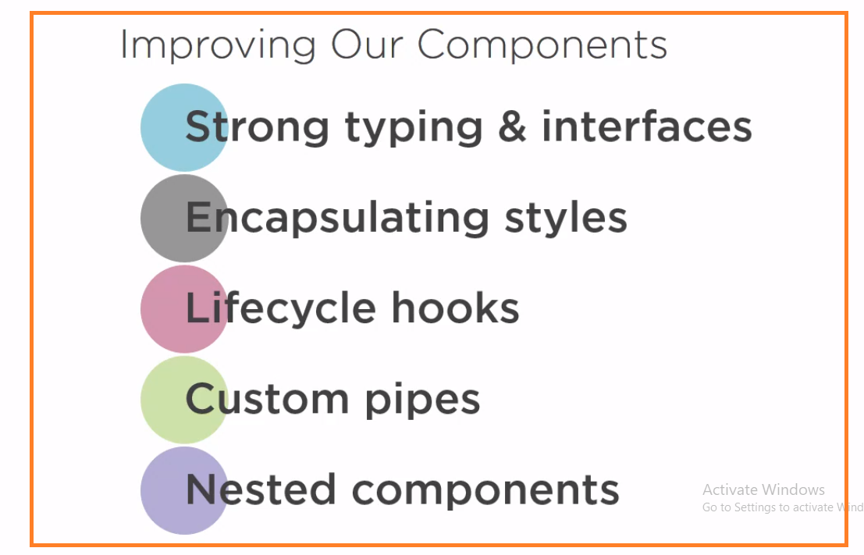

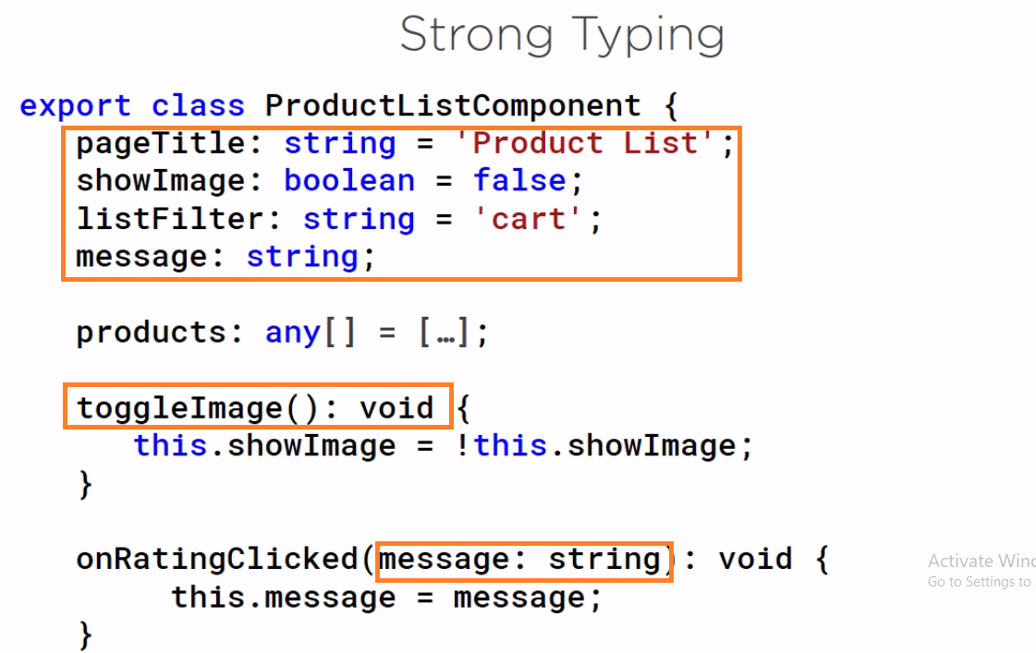

**Interface**

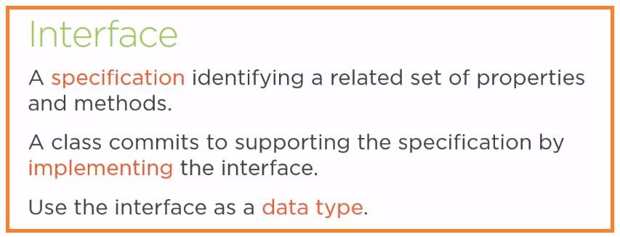

2nd point means the class includes code for each property and method identifies in the interface.

In 3rd point ES5 and ES2015 do not support interfaces, but typescript does, so interfaces are transpiled out and are not found in the resulting JavaScript. This means that interfaces are development time only. Their purpose is to provide strong typing and better tooling support as we build, debug and maintain our code.

Below is the example

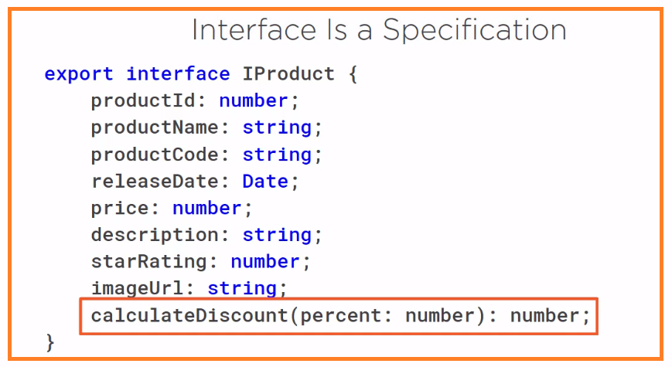

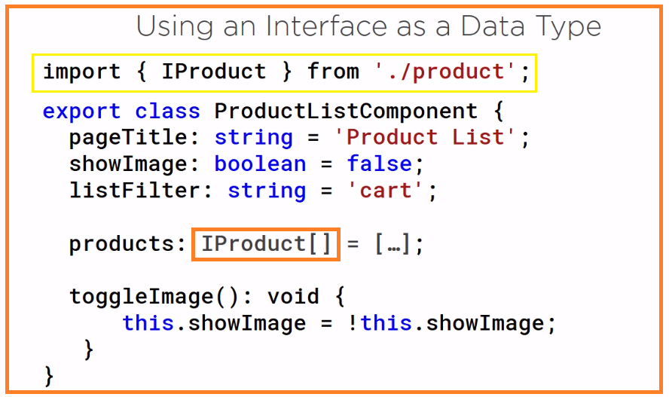

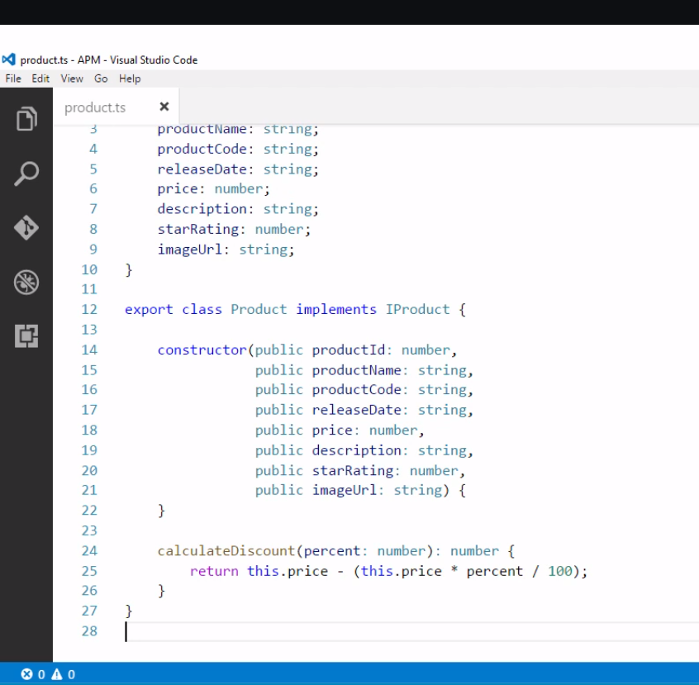

In our interface file, we could define a class for the product business object here as well something like above code. In general, we only create a business object class if that class provide some functionality that we want to use throughout our application, such as this **calculateDiscount** method. And if we think we might to create a business object at some point in the feature, then we definitely want to add the I prefix to our interface, but for our sample application, we don’t need any product methods, so we don’t really need a product class.

**Encapsulating component style**

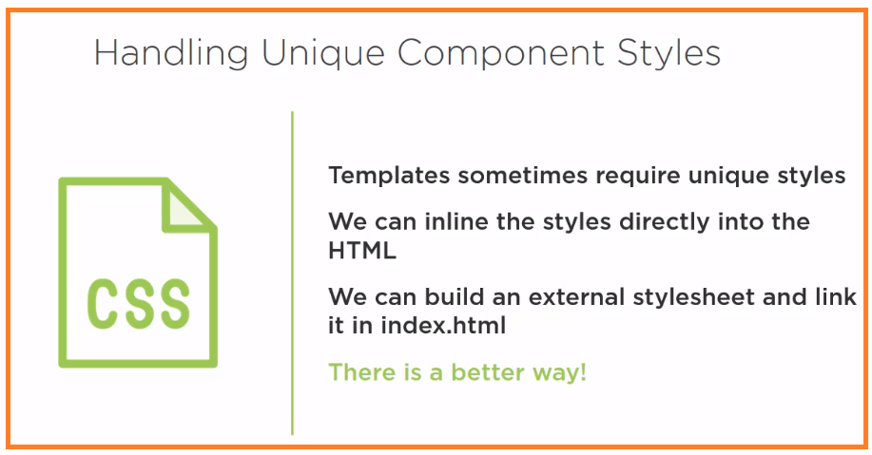

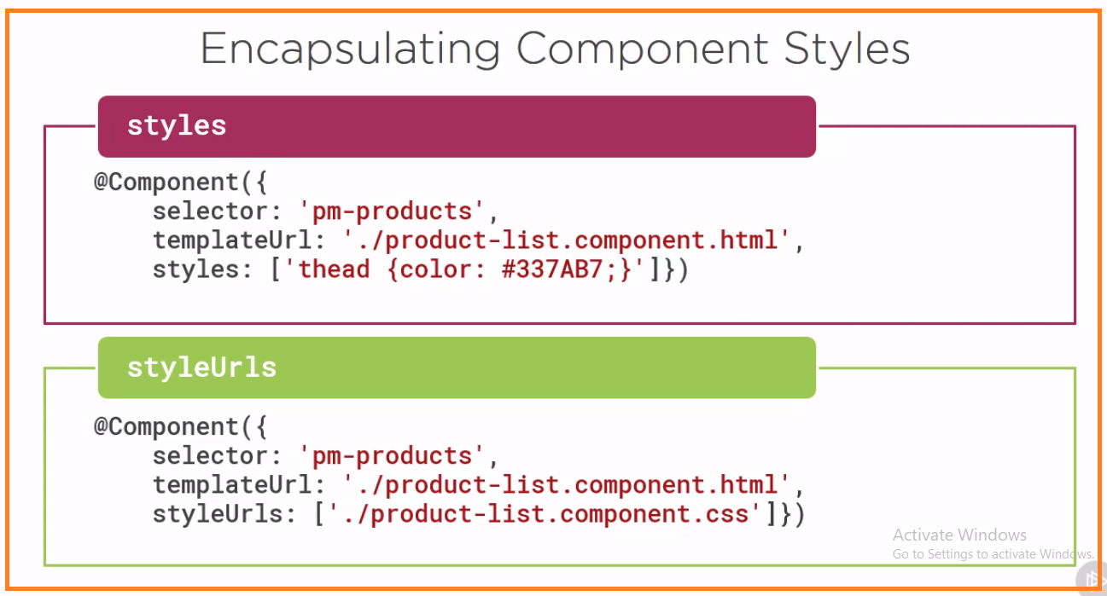

Component decorator has properties to encapsulate style as part of the component definition. These properties are style and styleUrls. We add unique styles directly to the component using the styles property. This property is an array, so we can add multiple styles separated by commas. A better solution is to create one or more external style sheet and identify them with the styleUrls property. This property is an array, so we can add multiple style sheets separated by commas. By encapsulating the styles within the component, any defined selectors or style classes are only applicable to the component template and wont leak out into any other part of the application.

**Life cycle hooks**

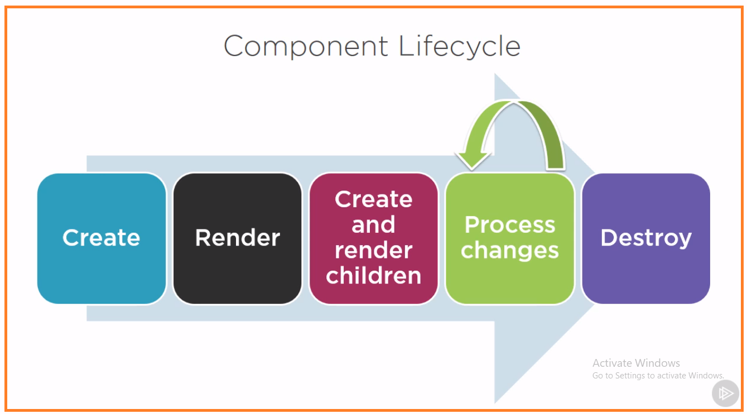

A component has a life cycle managed by Angular. Angular create the component, render it, create and renders its children, process changes checks it when it’s data-bound properties change, and then destroys is before it removing its template from the DOM. Angular provides a set of lifecycle hooks we can use to tap into this lifecycle and perform operations as needed.

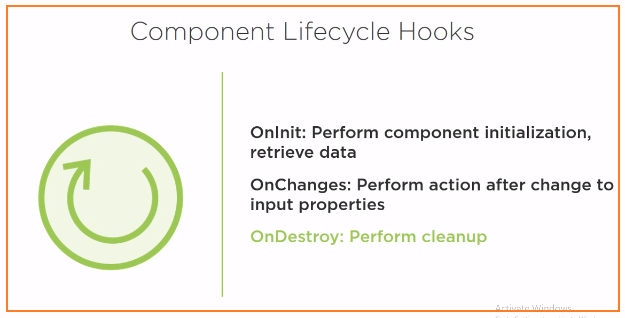

That is a very simple description of the sequence of events that an Angular component’s life experiences. These events are called “Lifecycle Hooks”.  Developers can use these lifecycle hooks to do something (run some code) whenever one of these events occur. There are eight different lifecycle hooks that a developer can tap into in any component or directive. To do so, a developer just needs to add one of the eight function calls that correspond to the lifecycle event. Add the hooks you need and leave out the ones you don’t.

* ngOnChanges()
* Used in pretty much any component that has an input.
* Called whenever an input value changes
* Is called the first time before ngOnInit
* ngOnInit()
* Used to initialize data in a component.
* Called after input values are set when a component is initialized.
* Added to every component by default by the Angular CLI.
* Called only once
* ngDoCheck()
* Called during all change detection runs
* A run through the view by Angular to update/detect changes
* ngAfterContentInit()
* Called only once after first ngDoCheck()
* Called after the first run through of initializing content
* ngAfterContentChecked()
* Called after every ngDoCheck()
* Waits till after ngAfterContentInit() on first run through
* ngAfterViewInit()
* Called after Angular initializes component and child component content.
* Called only once after view is initialized
* ngAfterViewChecked()
* Called after all the content is initialized and checked. (Component and child components).
* First call is after ngAfterViewInit()
* Called after every ngAfterContentChecked() call is completed
* ngOnDestroy()
* Used to clean up any necessary code when a component is removed from the DOM.
* Fairly often used to unsubscribe from things like services.
* Called only once just before component is removed from the DOM.

We will see 3 most commonly used life cycle hooks.

1. **OnInit** : OnInit lifecycle hook to perform any component initialization after angular has initialized the data bound properties. This is the good place to retrieve the data for the template from the backend service.
2. **OnChange** : to perform any action after angular set data bound input properties
3. **OnDestroy** : to perform any cleanup before angular destroys the component.

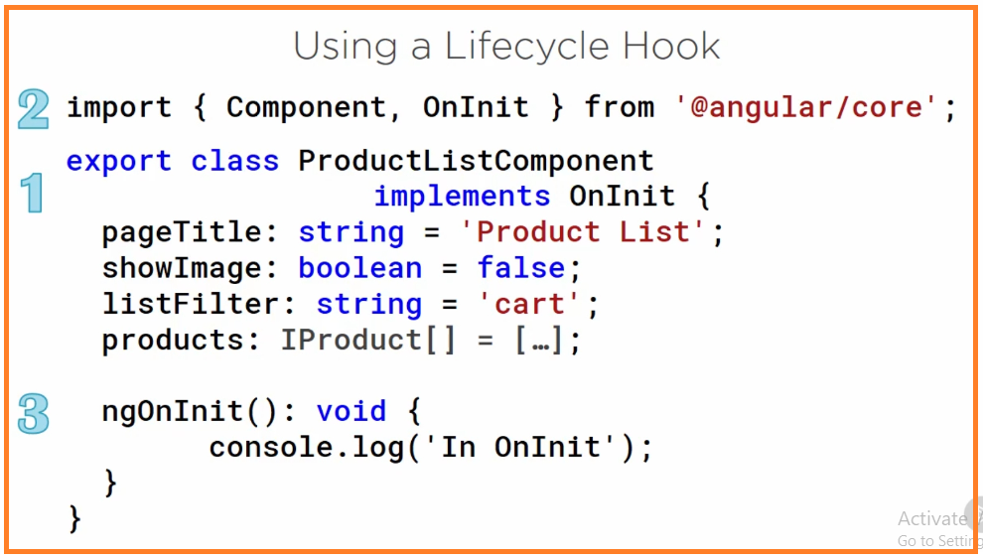

To use a lifecycle hook, we implement the lifecycle hook interface. Since angular itself is written in typescript, it provides several interfaces we can implement, including one interface for each lifecycle hook. For example, the interface for the **onInit** lifecycle hook is onInit. Notice that it is not prefixed with an “I”. we are using the onInit interface from angular. So, any guesses as to our next step? Yep, we need to import the lifecycle hook interface. We can then write the hook method. Each lifecycle hook interface defines one method whose name is the interface name prefix with ng for angular. For example. The onInit interface hook method is named ngOnInit. Our first step here of implementing the interface is actually optional. Recall from our discussion of interfaces earlier in this module that neither ES5 nor ES2015 support interfaces. They are features of typescript. That means that the interfaces are transpiled out of the resulting JavaScript, so we don’t really have to implement the interface to use lifecycle hooks. We can simply write code for the hook method. However, it is good practice and provide better tooling when we implement the interface. At this point in our application, we don’t need to implement any lifecycle hooks.

**Custom Pipe**

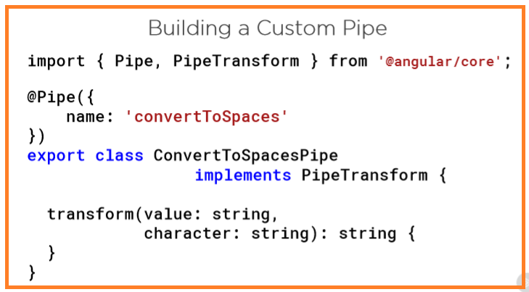

It uses pattern similar to other code we’ve created already. Here is the class. We add a pipe decorator to the class to define it as a pipe similar to the other decorator we’ve used. This is a function, so we add parentheses. We pass an object to the function specifying the name of the pipe. This is the name for the pipe used in the template as we’ll see shortly, we implement a pipe transform interface, which has one method transform. We write code in the transform method to transform a value and return it. The first parameter of the transform method is the value we are transforming. In this example, we transform a string. Any additional parameters defined arguments we can use to perform the transformation. In our case we want to pass in the character that we want to replace with space. The method returned type is also defined as a string because we are returning the transform string. And of course, we have our import what we need.

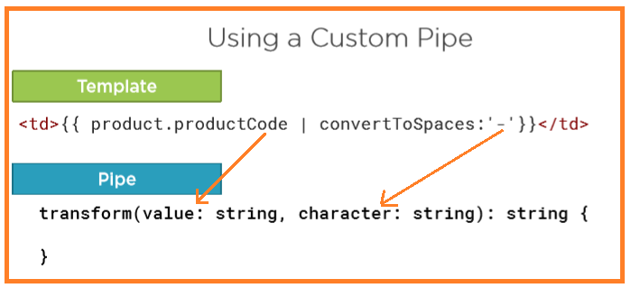

The product code pass as first parameter in transform method and – is pass as 2nd parameter in transform method.

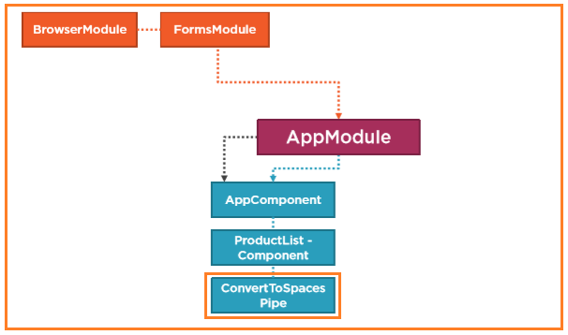

**Filtering and List**

The angular team and many experienced angular developers strongly recommended moving, filtering and sorting logic into the component itself.

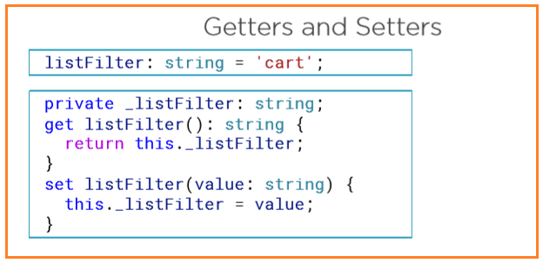

Let’s talk about JavaScript’s getter and setter’s, in JavaScript & Henson typescript. There are 2 way to define a property in a class.

1st We can declare a simple variable for a property

2nd we can define by using getter and setter

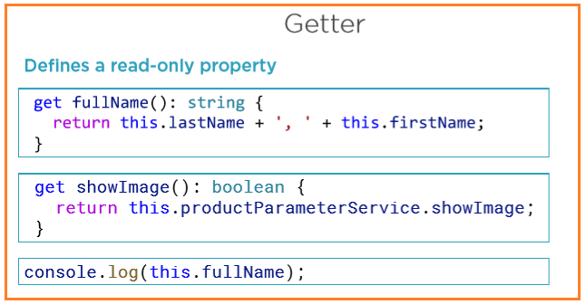

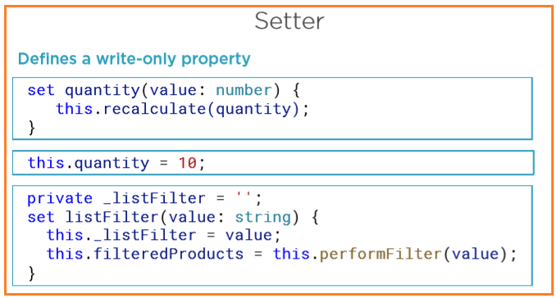

It must have one and only one parameter the set value and no return & field is private.

When we set value to setter there is no parenthesis (see 2nd marked)

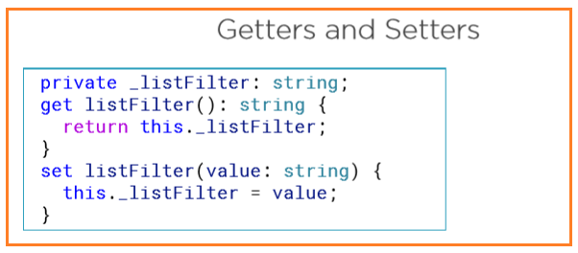

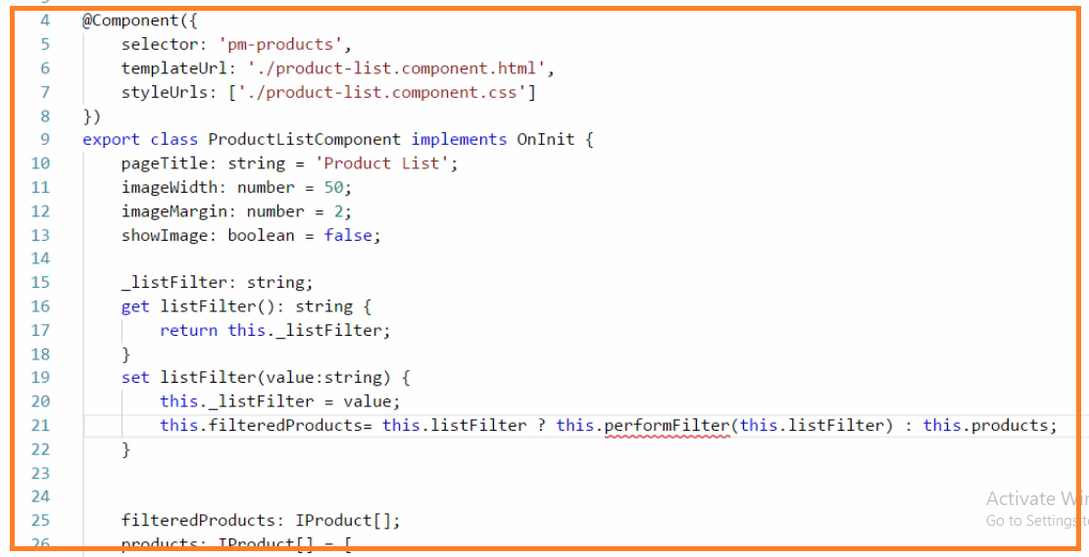

First, we need a filtered list of products that we combined to we can define a property for that here. Why don’t we just filter our product all right? Because once we filter the products array, we lose our original data and can’t get a back without re-getting that data from its source. Next, we need a way to know when the user changes the filter criteria. We could use event binding and watch for key presses or value change. But in easier way is to change our list, filter property into a getter and setter like this, the property, get her and set her work just like the simple property. When the data binding needs the value, it will call the getter and get the value. Every time the user modified the value, the data binding calls the setter passing in the changed value. If we want to perform so logic every time the value has changed, we can add it here in the setter. We want to set our filter product array to the filter list of products like this. Here we are using the JavaScript condition operator to handle the possibility that the list filter string is empty. No or undefined if there is a list filter value, this code filters on that value. If the list filter is not set, the filtered products property is assigned to the entire set of products, and that makes sense. If there no filter, we should display all of the products. But we skipped the messy part. What about this perform filter method?

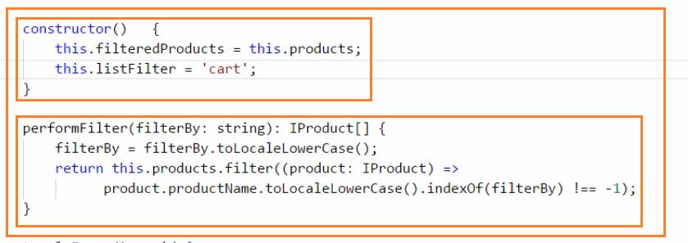

In perform filter we use the ES2015 arrow syntax to define that filter function. For each product in the list, the product name is converted to lowercase and indexOf is used to determine if the filter text is found in the product name. if so, the element is added to the filtered list. If we want to set default values for both the filtered products and the listFilter properties. We can use constructor. It is executed when component is initialized.

----------------------------------------------------------------------------------

**Nested Component**

There are 2 ways to use a component and display the component’s template. We can use the component as directive. we saw how to use a component as a directive when we displayed that app component template in index.html file. The pm-root directive is defined as the app component selector. The template is then displayed within the directive tag. We use the same technique with nested components. Alternatively, we can use a component as a routing target, so it appears to the user that they’ve traveled to another view. The template is then displayed in a full-page style view. Our product list view is currently used as a directive, but that’s only because we have not yet covered routing. (2nd way is use routing in component to display the template)

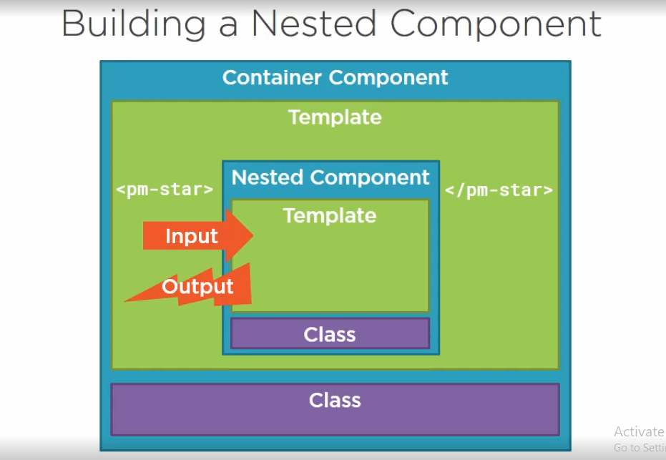

We refer to the outer component as the container or a parent component, and we refer to the inner component as the nested or child component. When building an interactive application, the nested component often needs to communicate with its container. The nested component receives information from its container using input properties, and the nested component outputs information back to its container by raising events.

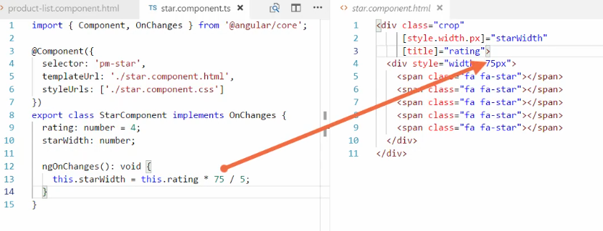

We will make star component and html for nested component.

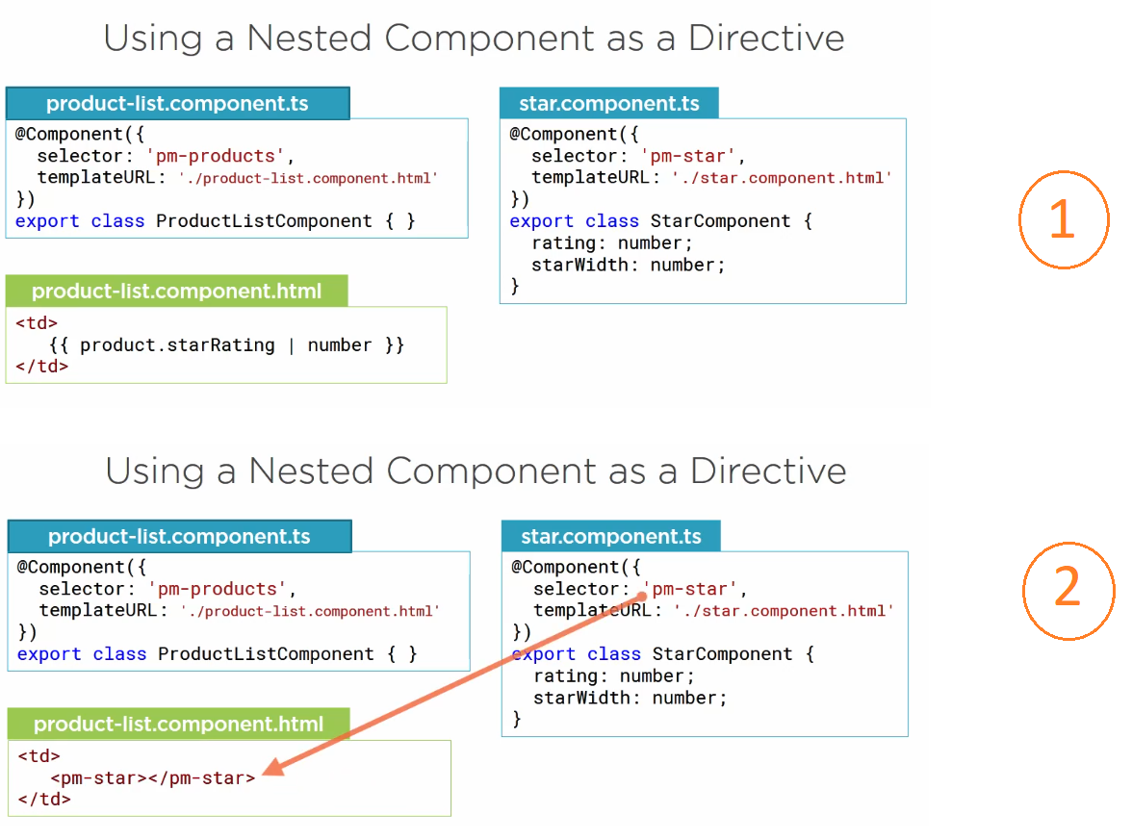

Replace 1st to 2nd to get star symbol instead of number

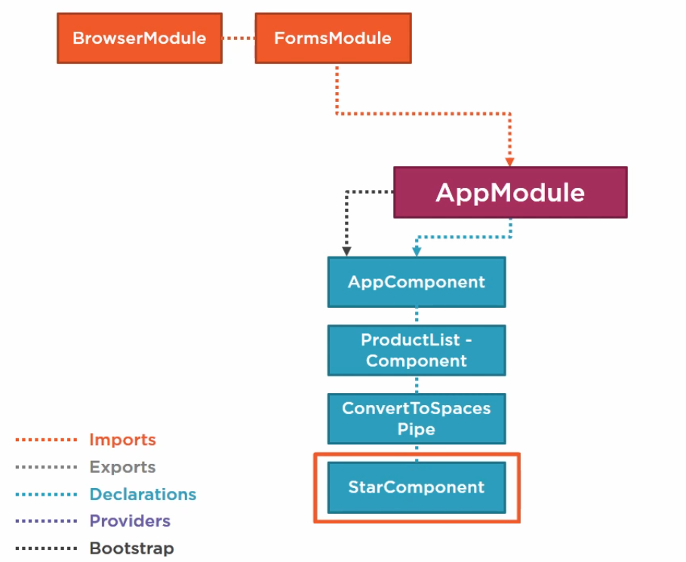

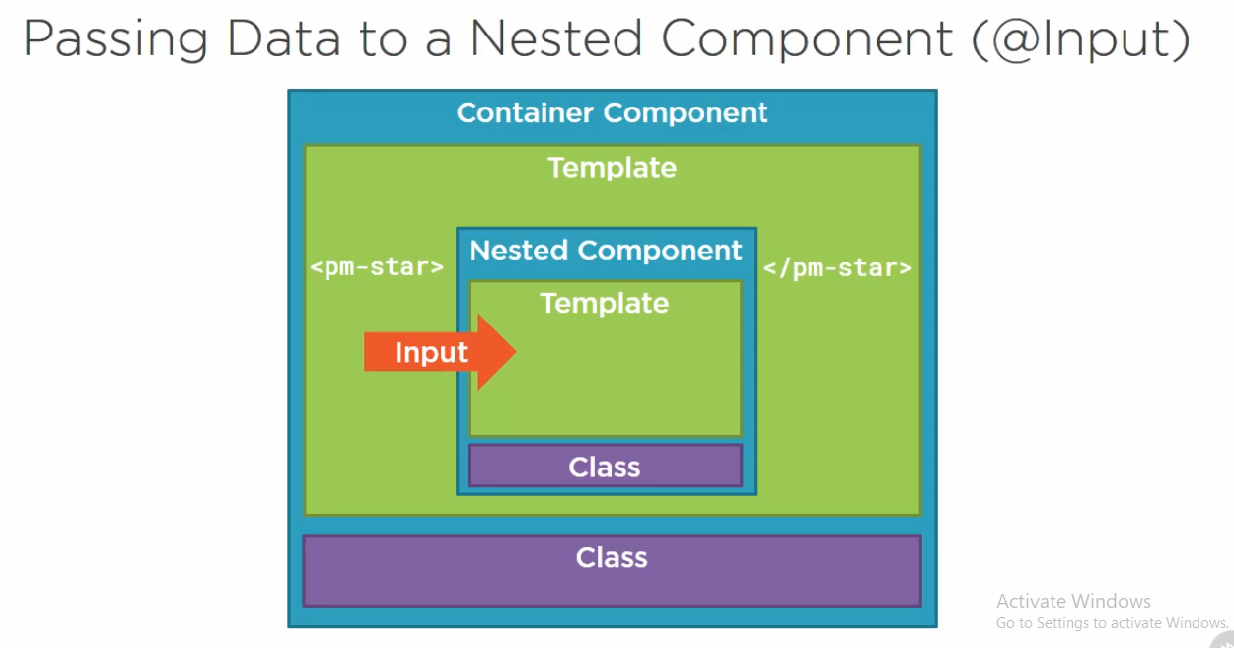

If the nested component wants to receive input from its container, it must expose a property to the container. The nested component exposes a property it can use to receive input from its container, using the app named input decorator (@Input).

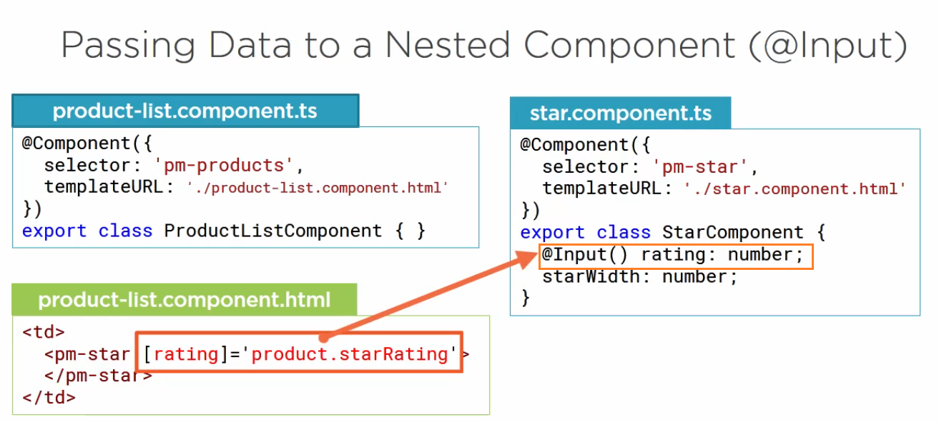

We use the @Input decorator to decorate any property in the nested component class. This work with any property type, including an object. In this example we want rating no passed into the nested component. So, we mark that property with the @Input decorator. The container component then passes data to the nested component by setting this property with property binding. When using property binding, we enclose the binding target in square brackets. We set the binding source to the data that the container wants to pass to the nested component. In this example, the product list template passes the product’s starRating number, the only time we can specify a nested component’s property binding target on the left side of an equals, is when that property is decorated with the input decorator. So, in this example product-list template can bind to the rating but not the start width.

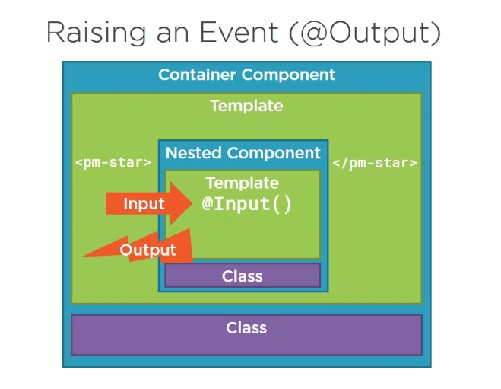

We just saw how the container passes the data to the nested component by binding to a nested component property that is decorated with the input decorator. If the nested component wants to send information back to its container, it can raise an event. The nested component exposes an event it can use the pass output to its container using the aptly named output decorator. We can put any no of @Output

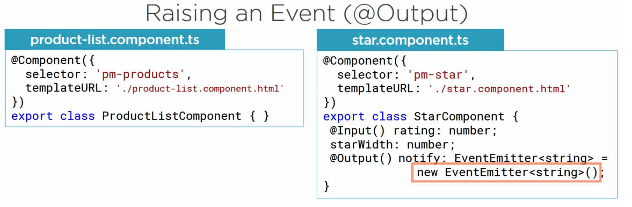

We can use the @Output decorator to decorate any property of the nested component’s class. However, the property type must be an event. The only way a nested component can pass data back to its container is with an event. The data to pass becomes the event payload. In angular, an event is defined with an EventEmitter object. So here we create a new instance of an EventEmitter. Note that it supports generics.

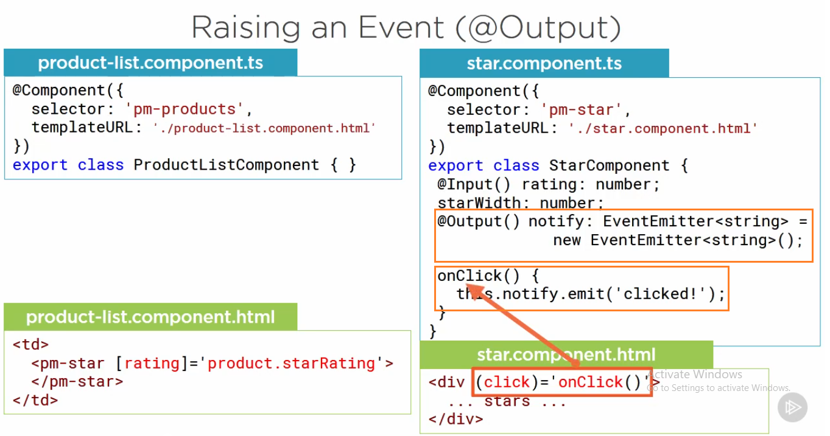

In this example, we define a notify event with a string payload. When the user clicks on the stars, the star component receives that click event. We use event binding in the Star component template to call the star component’s on click method.

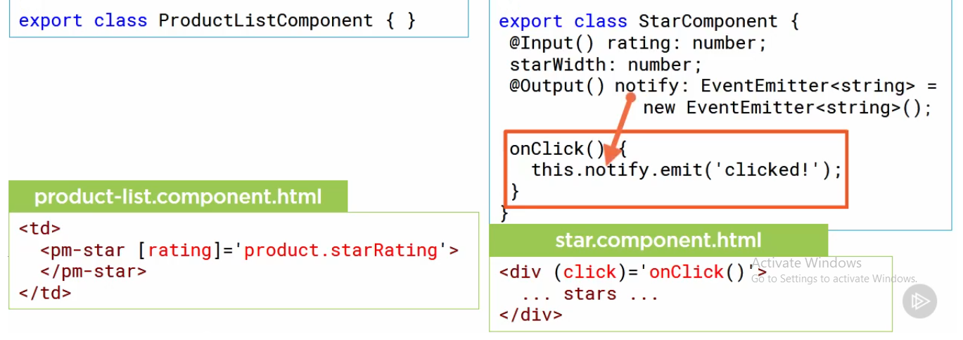

In the onClick() method, we use the notify event property and call it emit method to raise the notify event to the container. If we want to pass data in the event payload, we pass the data into emit method. In the example, the onClick method raises the notify event and sets the event payload to a string message.

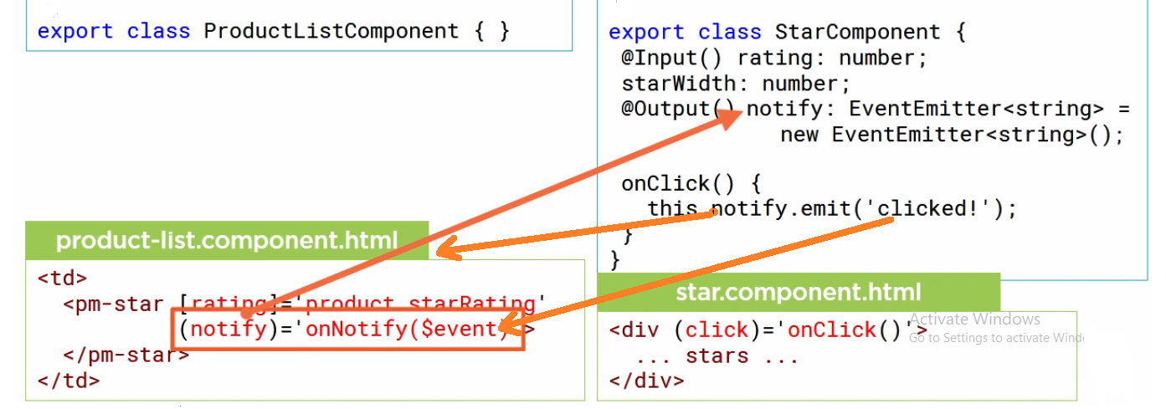

The container component receives that event with the specifies payload. In the container component’s template, we use event binding to bind to this notify event and call a method. We access the event payload using $event. The only time we can specify a nested component’s property as an event binding target on the left side of an equals is when the property is decorated with the output decorator.

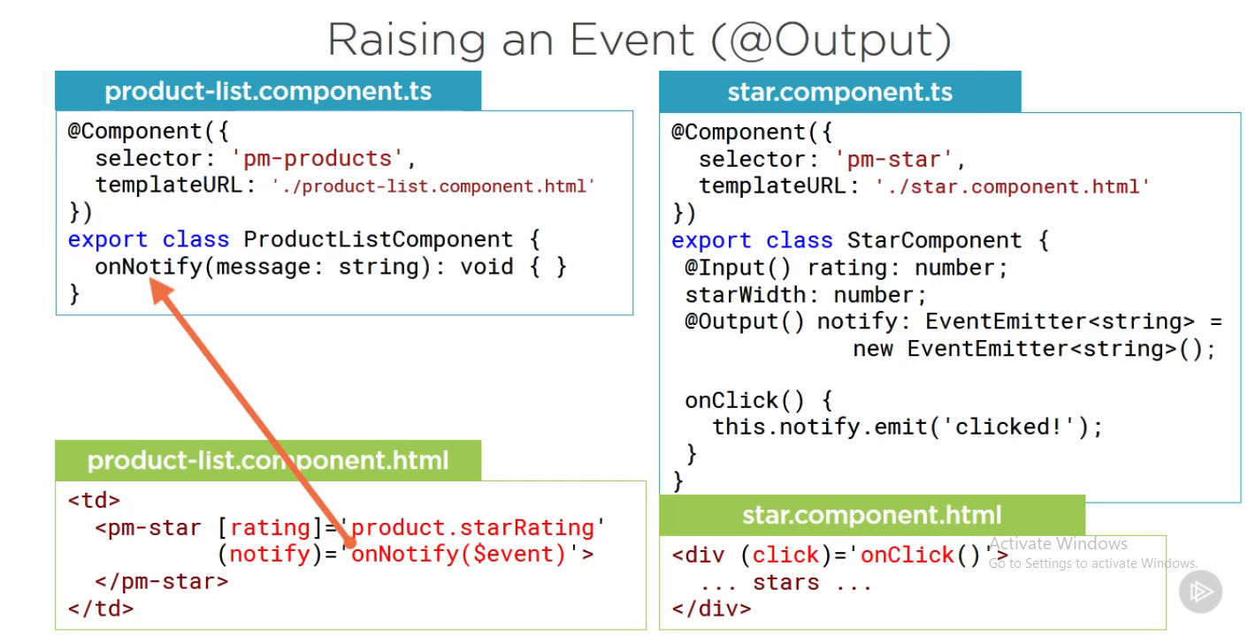

The container component provides the method to execute when the notify event occurs. Since the event payload is a string, the function takes in a string. And we can perform any desired action in method.

**Services**

We create a service and use dependency injection to inject that services into any component that needs it. Application often require services such as a product data services or a logging service. Our component depends on these services to do the heavy lifting. Wouldn’t it be nice it angular could serve us up those services on a platter? Well, yes, it can. But what are services exactly?

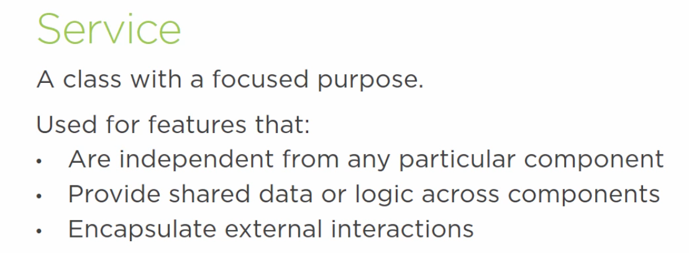

By shifting these responsibilities from the component to a service, the code is easier to test, debug and reuse.

**How does it work? How service and DI work?**

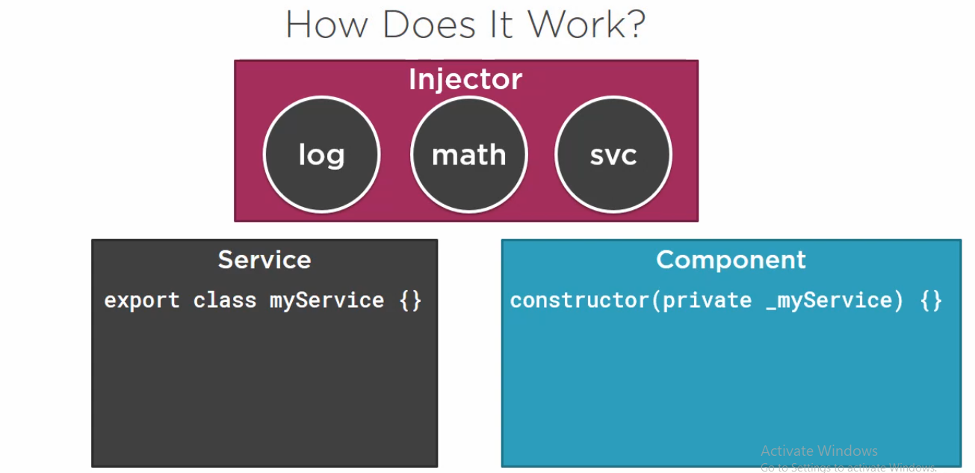

There are 2 way our component can work the component can create an instance of the service class and use it. That simple, and it works. But the instance is local to the component, so we can’t share data or other resources, and it will be more difficult to mock the service for testing. Alternatively, we can register the service with angular. Angular then creates a single instance of the service class, called a singleton, and holds onto it. Specifically, angular provides a built-in injector. We register our services with the angular injector, which maintain a container of created services instance. The injector creates and manages the single instance, or singleton, of each registered service as required. In this example, the angular injector is managing instances of three 3 different services: log, math and my service which is abbreviated svc. If our component needs a service, the component class define the service as a dependency. The angular injector the provides or injects, the service class instance when the component class is instantiated. This process is called DI. Since angular manages the single instance, any data or logic in that instance is shared by all of the classes that used it. This technique is the recommended way to use services because it provides better management of service instance, it allows sharing of data and other resources, and it’s easier to mock the services for testing purposes.

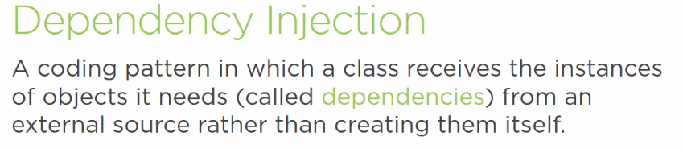

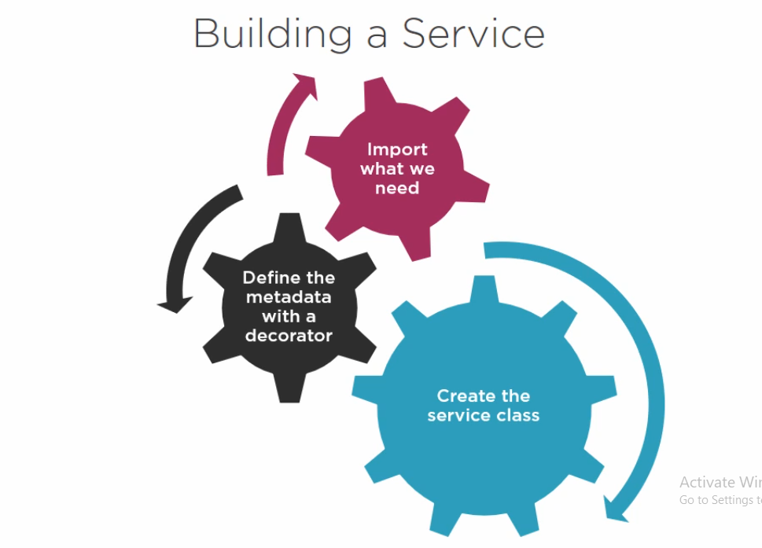

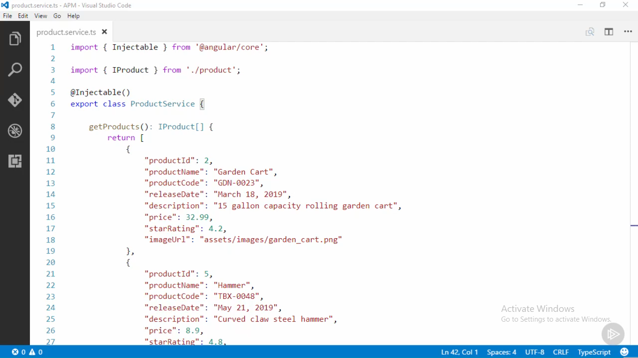

we have no properties define in this class, so we are not using this particular service to share data

we are using it to encapsulate the data access feature, by using this service provide the list of products we take the responsibility for managin the data away from the individual component, that makes it easier to modify or reuse the logic

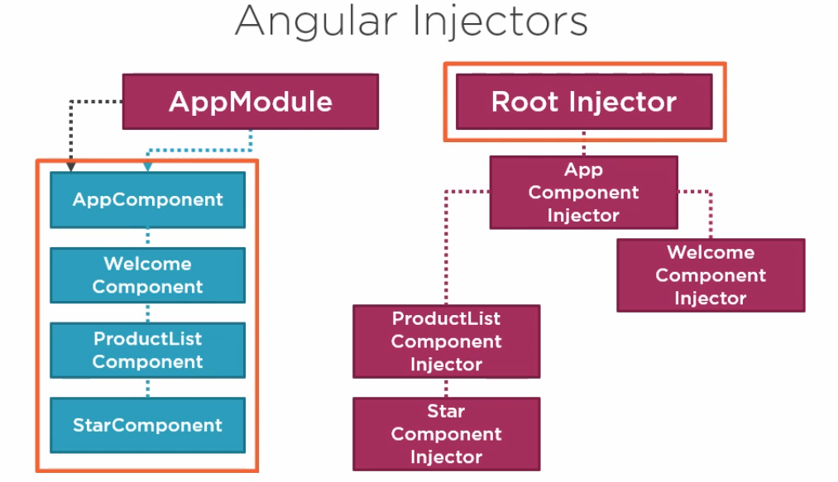

We register the service with the angular injector, and the injector provides the service instance to any component that injects it using the constructor. The injector represented here is the root application injector, but wait, there’s more. In addition to the root application injector, angular has an injector for each component, mirroring the component tree. A service registered with the root application injector is available to any component or other service in the application. A service registered with a specific component is only available to that component and its child or nested components.

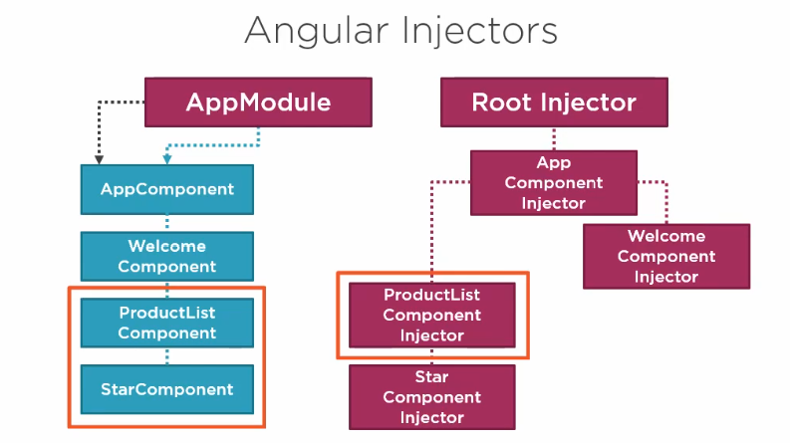

For example, if a service is registered with the ProductList components injector, the service is only available for injection in the product list component and its child, the StarComponent.

So, when should you register your service with the root injector vs component injector? Given below

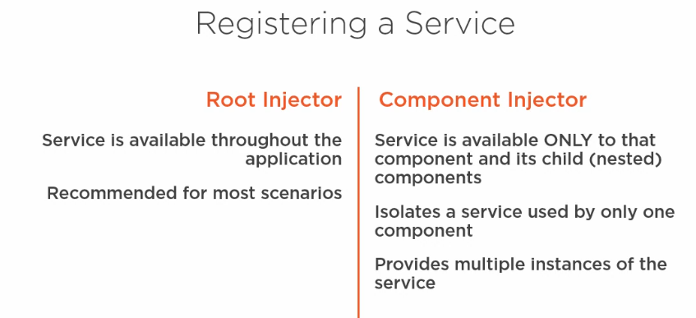

**To register service**

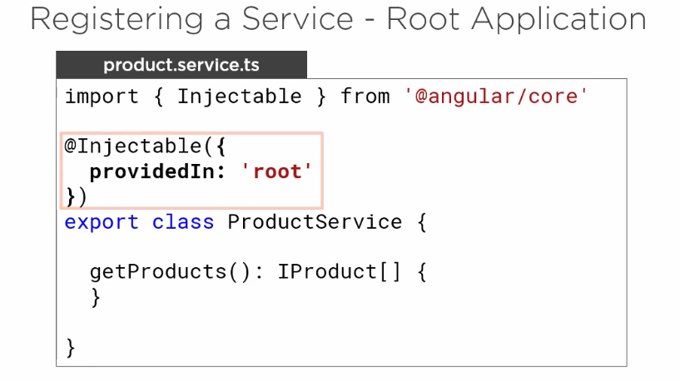

We pass an object into the injectable decorator and set the “providedIn” property to root. We can then access the service from any component or other service in the application. We went to use our ProductService in several components, so we’ll register it with the root application injector.

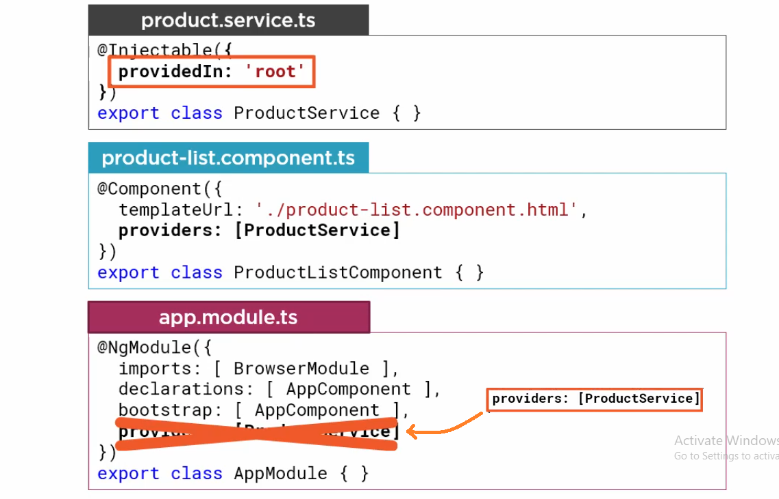

1. For most scenario we’ll resister our service using the providedIn property. The service is then available to the entire available.
2. To resister or service for specific component, such as ProductListComponent, we register the service in that component like above. The service is then available to the component and its child components.
3. Note that the providedIn feature is new in angular version 6. In older code, you’ll see the service registered in a module. The syntax is still valid; however, the recommended practice is to use the new providedIn feature in the service instead. This provide better tree shaking. Tree shaking is the process whereby the angular compiler shakes out unused code for smaller deployed bundles.

**Injecting the service**

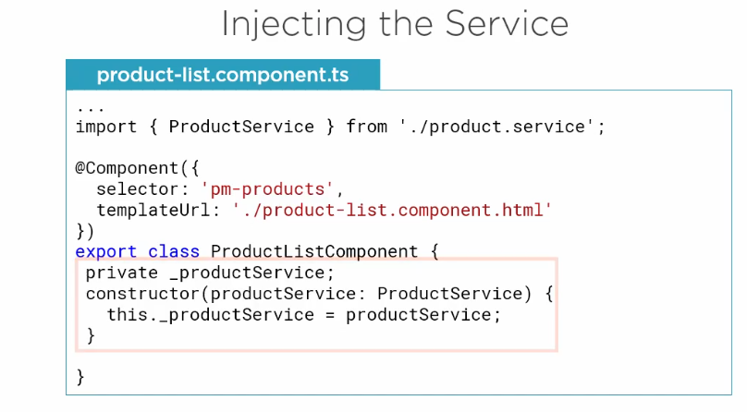

Every class has a constructor that is executed when an instance of the class is created. If there is no explicit constructor defined for the class, an implicit constructor is used, but if we want to inject dependencies such as instance of a service, we need an explicit constructor. In typescript, a constructor is defined with a constructor function. What type of code normally goes into the constructor function? As little as possible. Since the constructor function is executed when the component is created, it is primarily used for initialization and not for code that has side effect or takes time to execute. We identify our dependencies by specifying them as parameters to the constructor function. Here we define a private variable to hold the injected service instance. We created another variable as the constructor parameter. When this class is constructed, the angular sets this parameter to the injected instance of the requested service. (same as java constructor)

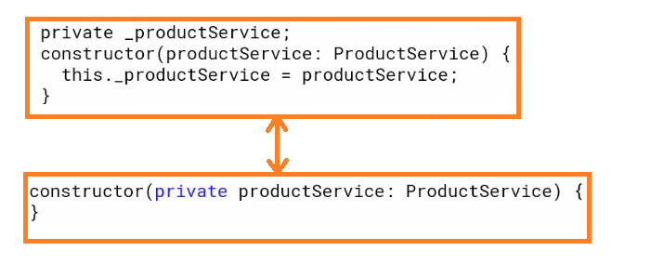

We simply add accessor keyword. Such as private here, to the constructor parameter. Then this is a shortcut for declaring a variable, defining a parameter, and setting the variable to the parameter. You’ll see this technique used throughout the angular documentation and other code examples. The syntax work with public and protected as well.

We’ll define our product service as a dependency in the product list component. We don’t have to add providers array here, because the product service is already registered. All we need is a constructor, and we already have one here.

**Retrieving data using http**

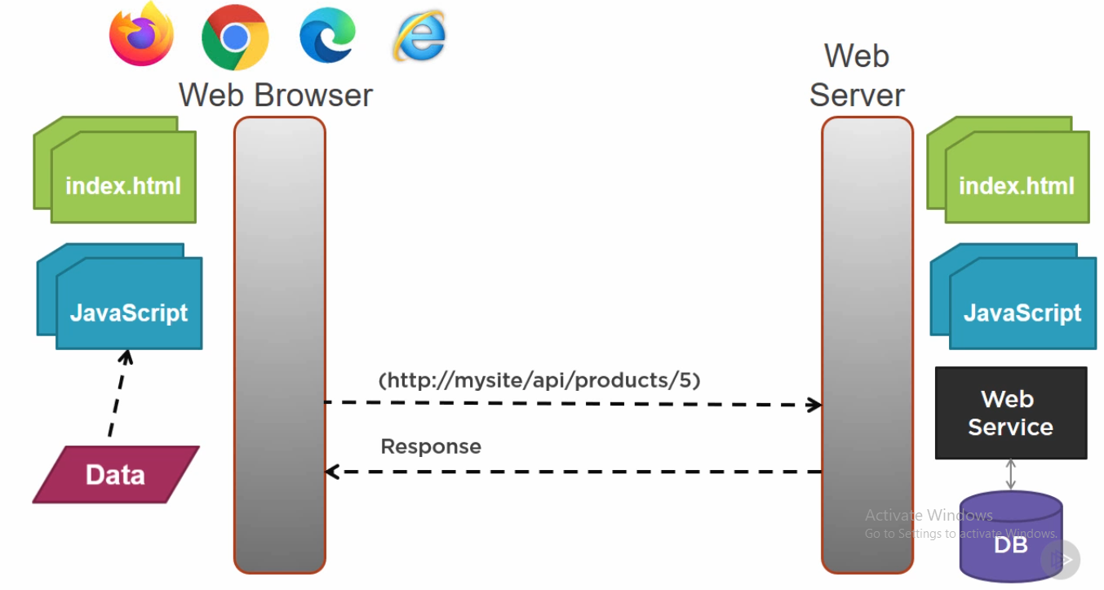

**Observable and reactive extension**

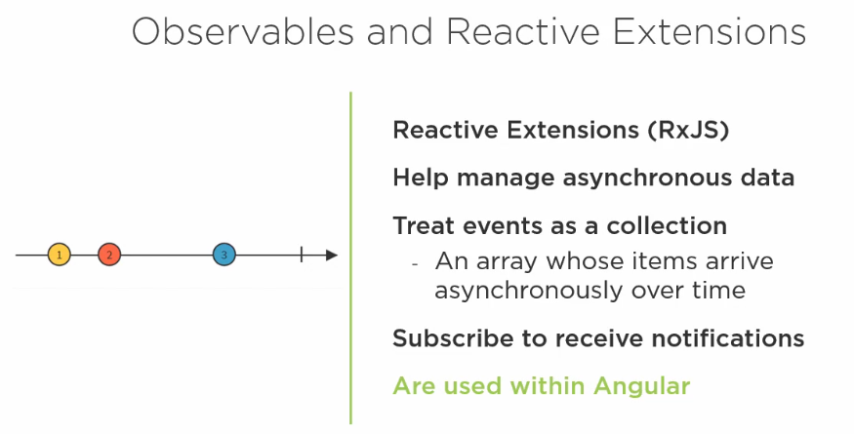

Data sequences can take many forms, such as a response form, back end webservice, a set of system notifications, or a stream of events such as user input. In this diagram our stream contains 3 elements. The 1st marble comes in, then 2nd and sometime later the third. **Reactive extensions represent a data sequence as an observable sequence, commonly just called an observable.** Observable help us manage asynchronous data, such as data coming from a back-end server. Observable treat events as a collection. We can think of an observable as an array whose items arrive asynchronously over time. A method in our code can subscribe to an observable to receive asynchronous notification as a new data arrives. The method can then react as data is pushed to it. The method is notified when there is no more data or when an error occurs. Observable are used within angular itself, including angular’s event system and its HTTP client service, which is why we are covering them here.

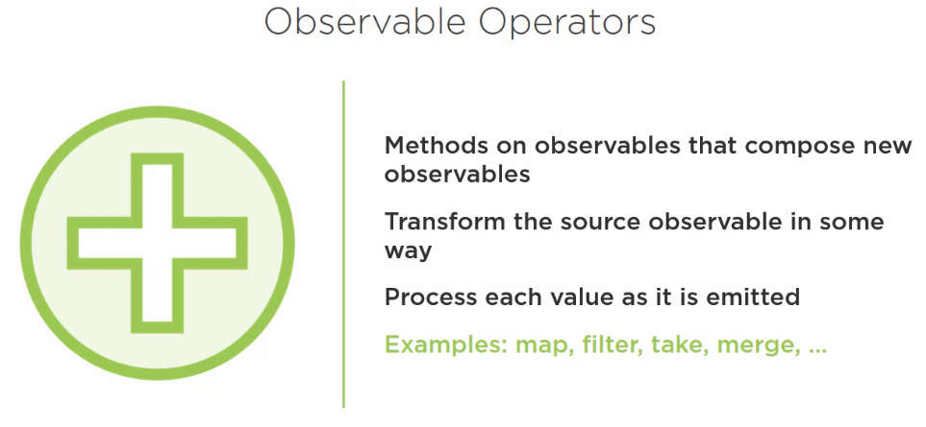

Observable allow us to manipulate sets of events with operators. Operators are method on observables that compose new observables. Each operator transforms the source observable in way. Operators do not wait for all of the values and process them at once. Rather, operators on observable process each value as it is emitted. Some example of operators include map, filter, take and merge.

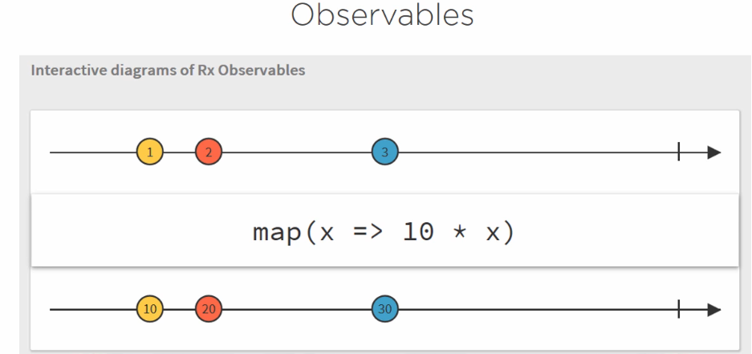

The map operator allows us to transform the incoming data. The argument to the map operator is an arrow function that says to take each data item and transform it to 10 times its value. So, when we receive 1, it is mapped to 10. When we received 2, it is mapped to 20 and so on. This depiction is called a marble diagram, and it’s helpful for visualizing observable sequences. This is screenshot from rxmarble at this URL.

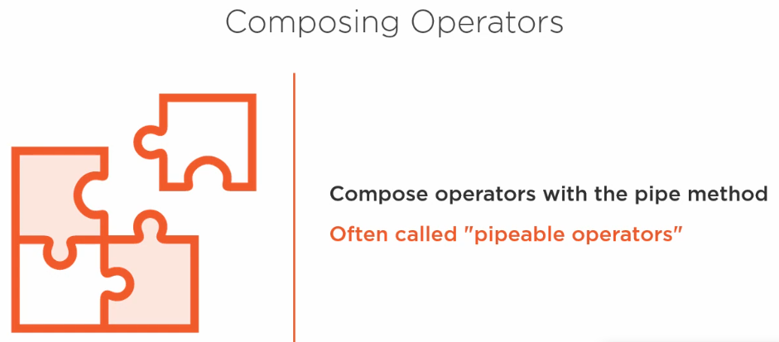

We compose observable operators with the observable pipe method, hence the reason that observable operators are sometimes referred to as pipeable operators.

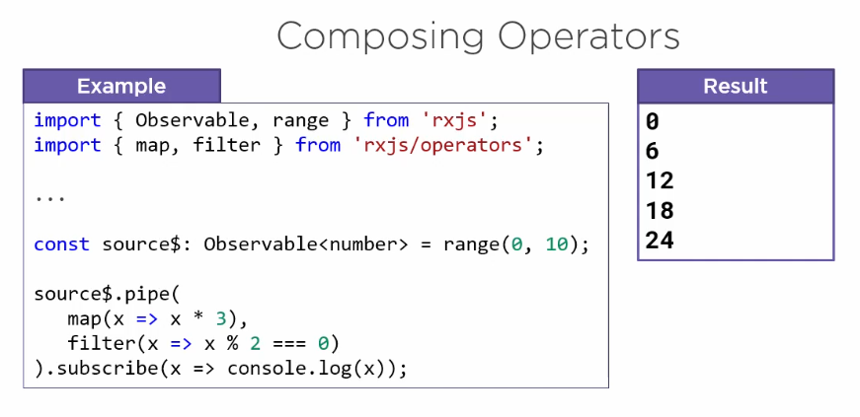

Let’s look at example, we see how to use the pipe method to compose multiple observable operators. Rxjs has 2 primary packages we use to import functionality. Observable and the observable creation methods, such as range, can be found in the rxjs package. We import the operators from rxjs/operators. We use range creation method to create an observable stream of number from 0 to 9. Not a common scenario, I know, but our goal here is to show how to compose operators with the pipe. By convention, we add a dollar suffix to the variables that hold an observable. This makes it easier to quickly distinguish the observables in our code, and we declare its type as an observable stream of numbers, using the generic argument. We use to pipe method to pipe this observable stream through several operators, map and filter. We only include 2 operators here, but we can define any number of operators separated by commas. This map operator takes each number emitted into the observable stream, 0 through 9, and multiplies by 3, which results in an observable with 0, 3, 6, 9 and so on. As each number is emitted by the map operator, this filter operator filters the result to only the event number in the sequence. That is those that when divided by 2 have a remainder of 0. Here we subscribe to the resulting observable to start receiving emitted values. The observation source does not emit any values until it has a subscriber. So subscribing is key. What do you think will be logged to the console? How we got that result. The source emits 0 the 0 is multiply by 3, resulting in 0. The 0 is divided by 2 with a remainder of 0, so it is included in the final result. The source then emits 1. The 1 is multiplied by 3, resulting in 3. The 3 is divided by 2 with the reminder of 1, so it is not included in the final result, and so on. Notice that each item in the sequence is processed through the pipeable operators as it is emitted.

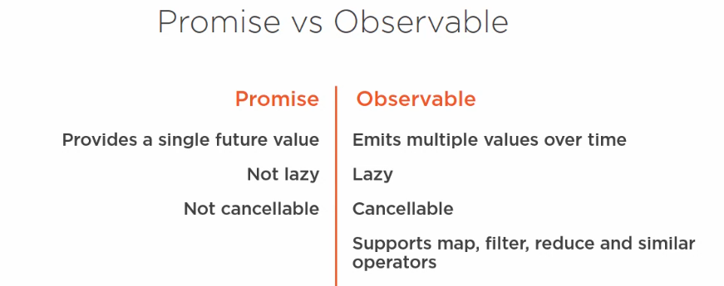

You may have worked with asynchronous data in JavaScript previously, using promises. Observables are different from promises in several ways. A promise returns a single future value. An observable emits multiple asynchronous values over time. A promise is not lazy. By the time you have a promise, it’s on its way to being resolved. An observable is lazy by default. Observables will not emit values until they are subscribed to. A promise is not cancellable, it is resolved or rejected, and only once. An observable can be cancelled by unsubscribing, plus an observable supports map, filter, reduce and similar operators. In this module, we’ll do HTTP using observables.

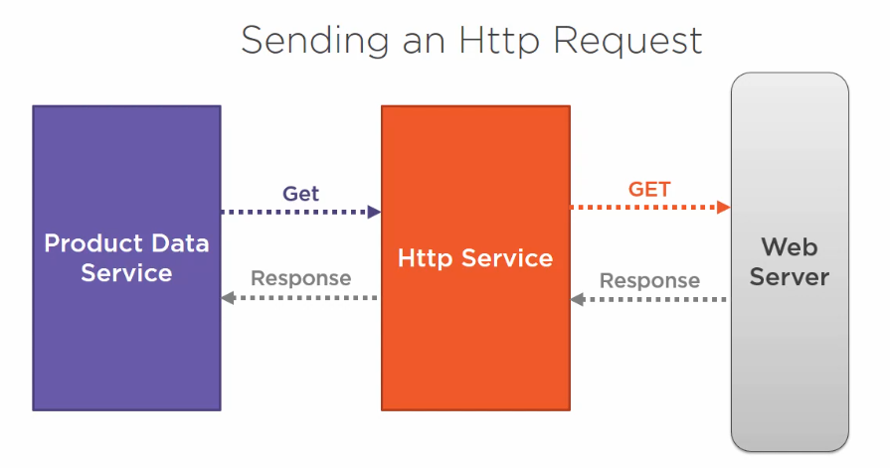

Our product data service contains hardcoded list of products. We instead, want to send an HTTP request to get the product from a backend web server. Angular provide an HTTP service that allow us to communicate with a backend web server using the familiar HTTP request and response protocol.

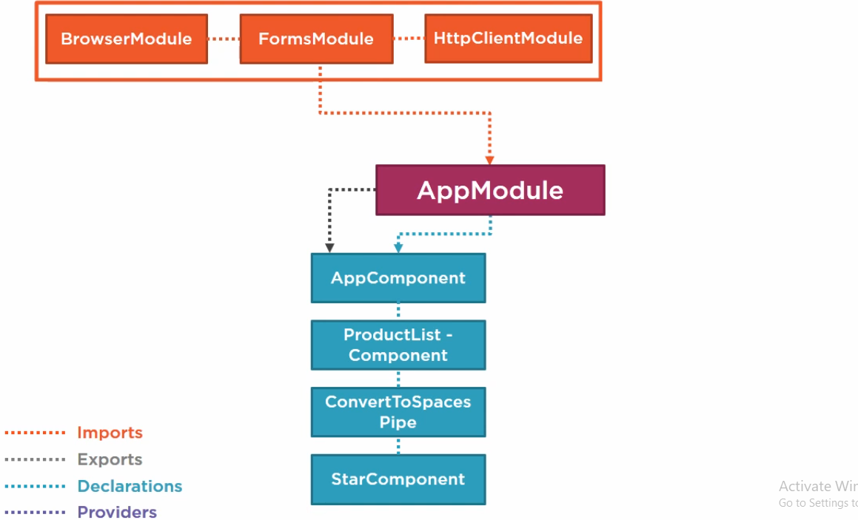

If we are using HttpClienModule then our architecture like above.

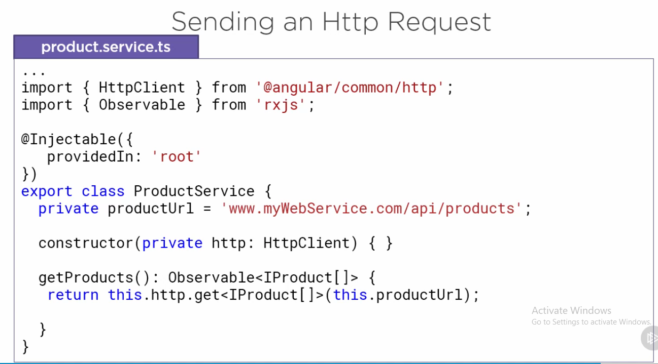

The data return from the backend server will be JSON. The HttpClient get method makes it easy to receive that JSON data. We specify the expected type of response by setting the get method generic parameter. It’s important to note that HTTP calls are single asynchronous operator, meaning that the observable sequence (observable<Iproduct[]>) returns from the get method contain only one element. This element is the http response object mapped to the typed specified in the generic parameter. Notice that the observable also takes advantages of generic to define the type of data it is observing in the observable sequence. In our case it’s the array of product.

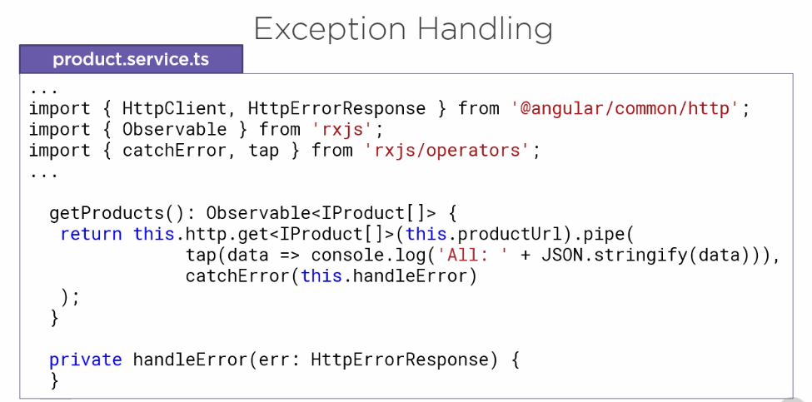

As you can imagine, there are many things that can go wrong when communication with a back-end server. Everything from an invalid request to a lost connection. So, let’s add some exception handling. There are 2 key observable operators that we’ll need. Tap taps into the observable stream and allow us to look at the emitted value in the stream without transforming the stream. So, tap is great to debugging or logging. As we discussed earlier in this course, to use these operators, we access the pipe method of the observable. We then pass into the operators, separated by commas. Here the tap operator logs the retrieved data to the console. That way we can verify it’s been retrieved correctly. And the catchError operator takes in an error handling method (handleError). The error handling method gets one parameter, the ErrorResponse object. In the error handling method, we can handle the error as appropriate. We can send the error information to a remote loggin infrastructure or throw an error to the calling code.

**Subscribing to an observable**

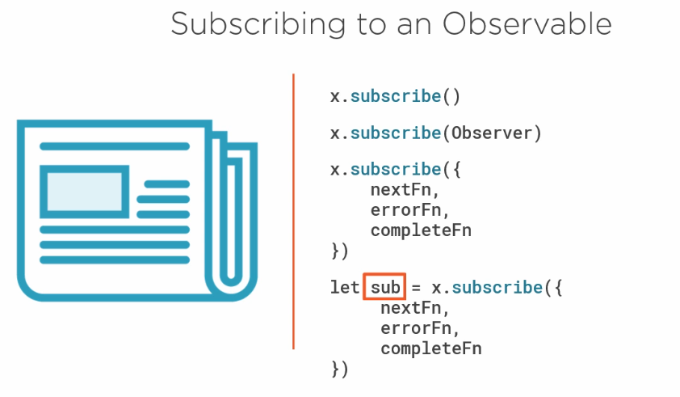

Observables are lazy. Just like a newspaper or newsletter, an observable doesn’t emit values until we subscribe. So, we are ready to start receiving values in our component, we call subscribe. The subscribe method takes an optional argument, which is an observer object. As its name suggests, the observer object observes the stream and responds to three type of notifications next, error and complete. We use the observer object to define handler functions that execute on these notifications. The first handler function is often called a next function (nextFn) because it processes the next emitted value. Since observable can handle multiple values over time, the next function is called for each value the observable emits. The second is an error handler function (errorFn). And yep, you guess it, it executes if there is an error. In some cases, we want to know when the observable completes, so observable provide a third handler (completeFn) that is executed on completion.

The subscribe function returns a subscription. We use that subscription to call unsubscribe and cancel the subscription, if needed.

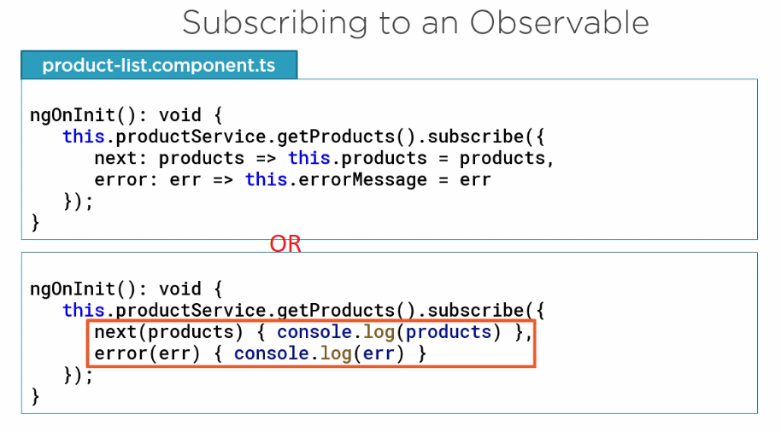

The product data service is returning an observable, any class that needs product data, such as our ProductListComponent, can call our service and subscribe to the returned observable. This line of code calls the product data service getProducts method, and because we subscribed, it kicks off the HTTP GET request. It then asynchronously receives data and notification from the observable. We pass an observer object to the subscribe.

Only use 2nd i.e. alternate syntax if you don’t need to reference class-level properties.

**Navigation and Routing Basics**

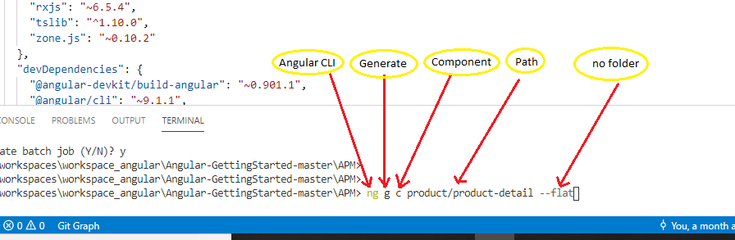

To create component using Angular CLI and it also update our angular-module.ts (html, css, ts etc)

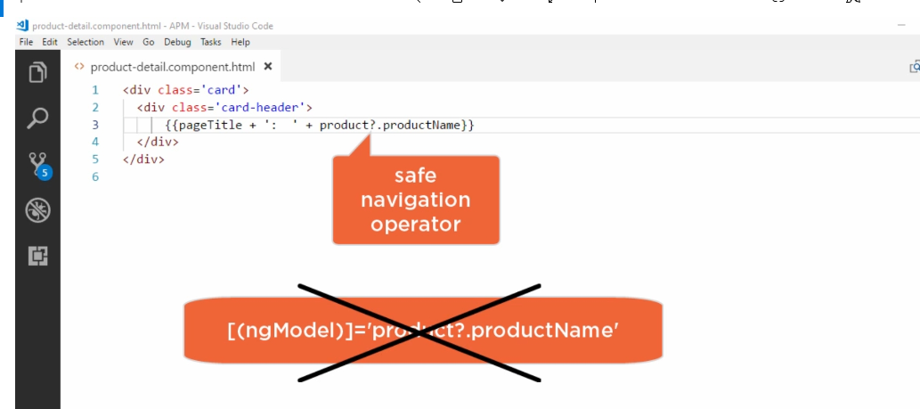

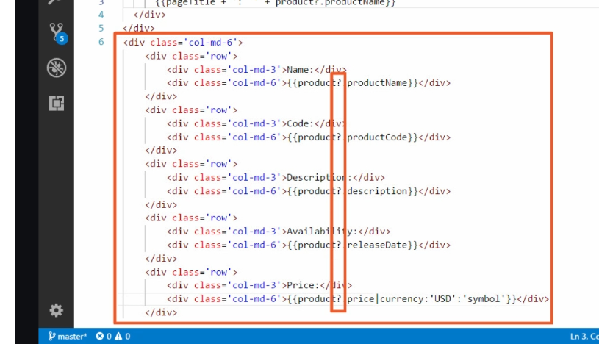

? means safe navigation operator guard against null or undefined values when navigating and object properties. If object property null or undefined the safe navigation operator simply return null and does not attempt to access the product name property. Hence, we don’t see an undefined property.

It is the good but not always the best option. For example, it does not work when used with ngModel 2-way binding quitter tedious when we display many properties, like in our details.

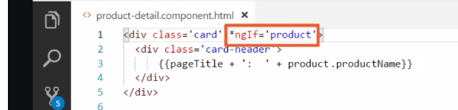

So, there is another option *ngIf. We don’t need to use safe navigation operator.

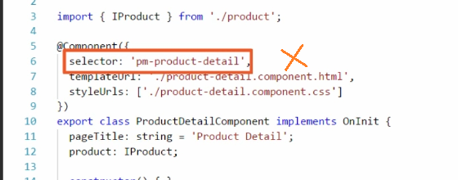

Go to typescript. Notice, that the CLI generate the selector property here. The selector property is only required if the component will be nested with another component. We won’t need to nested component will instead display the components view as part of the routing. So, delete the selector.

Now add the welcome-component without CLI.

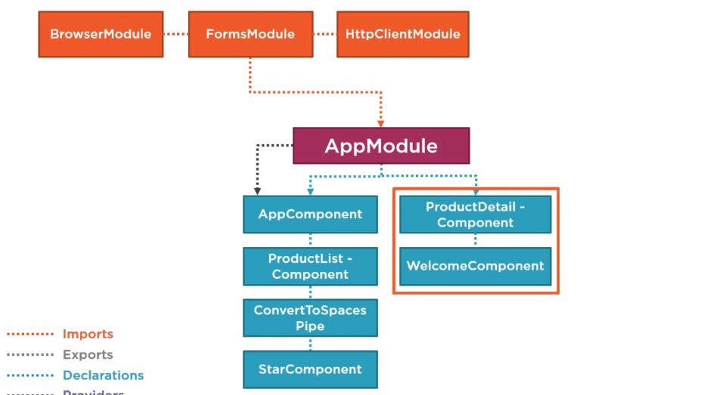

**How Routing Work**

An angular application is SPA. That means all of our views are displayed within one page, normally defined in the **index.html** file. So, each of the 5 10 or 100 of views. take turns appearing on that one page. How do we manage which few to display when that’s the purpose of routing? we configure a route for each component that want to display its view on the page. As part of our application design, we provide a menu, a toolbar, button, images or data link that allow the user to select the view to display. We tie around to each option or action. When the user selects the option or perform the action, the associated route is activated. Activating a components route to displays that components view. So, for example, the user selects a menu option to display the product list. The product list is activated, and it displays its view.

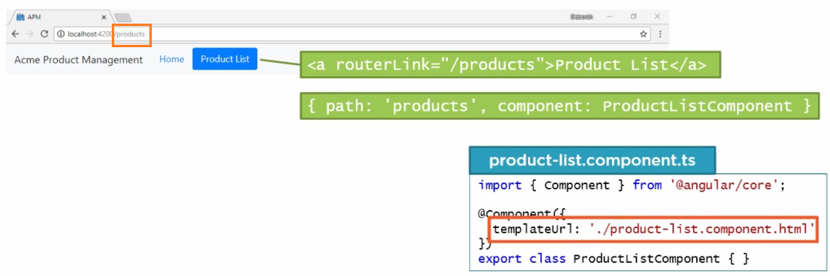

When the user clicks on the product list option. For example, the angular router navigates to the product route the browsers location URL changes to match this past segment, and we see /product appear in the address bar by default.

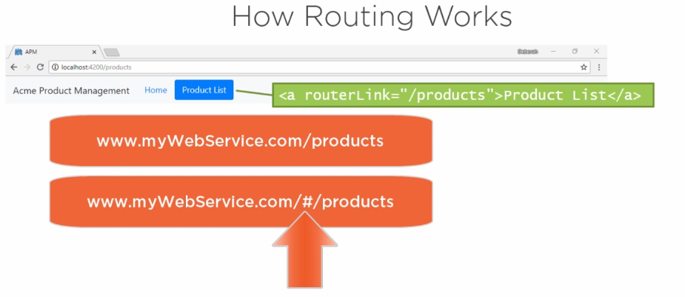

Angular uses HTML five style URL which don’t require the # symbol to indicate local navigation. By using the HTML five style URL, you need to configure your web server to perform URL rewriting. How this is done depends on your web server. Angular also support #style routing, which does not require URL rewriting.

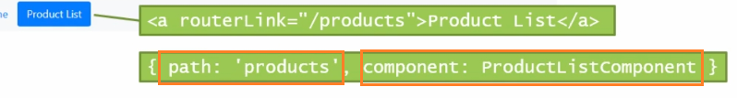

When the browser URL changes, the angular router looks for a route definition, matching the path segment products. In this example, the route definition includes the component to load when this road is activated in this case, the product list component. The angular router then loads the components template. Where does it display this template? Where we specified with the belt in routing directive called router outlet and the product list appears so that’s how routing works will examine these steps and further detail.

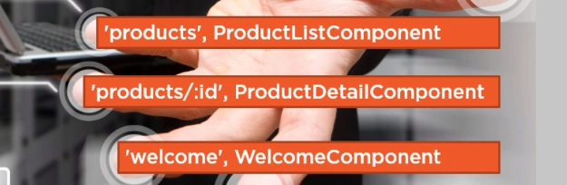

Routing is component based, so we identify the set of components that we want to provide as routing targets and to find a route for each one.

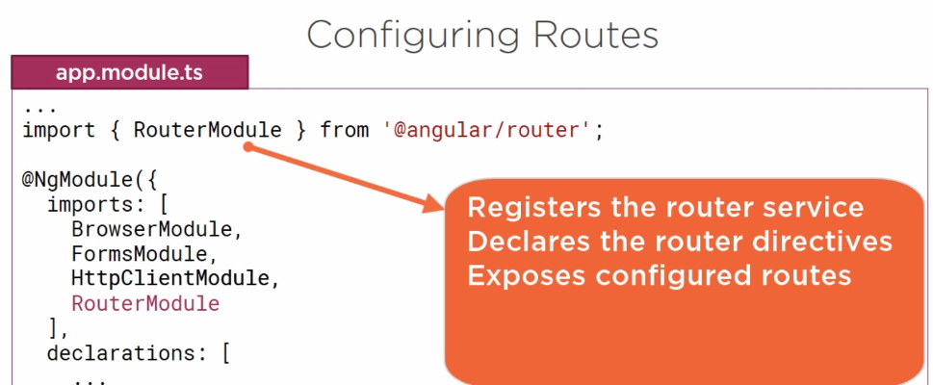

An angular application has one router that is managed by Angular’s router service, and we know that before we can use a service, we need to resister the service provider in an angular module. Similar to Http Module, Angular provide a RouterModule in the angular/router package that resisters the router service provider. To include the features of this external module in our application, we need to add it to the import array of our application’s angular module.

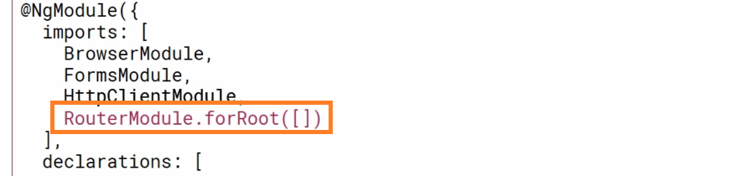

**OR**

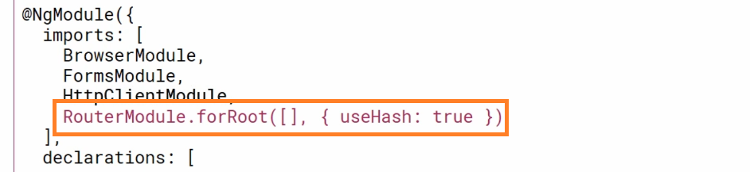

In addition to registering the service provider, the router module also declares the router directives. In the last clip we mention 2 router directives, RouterLink and RouterOutlet. By importing the RouterModule our component templates can use these or any other router directives. RouterModule also expose the routes we configure. Before we can navigate to route, we need to ensure that the routes are available to the application. We do this by passing the routes to routerModule like **RouterModule.forRoot([])** we pass array of routes to that method. This establish the routes for the root of our application. If we want to use #style route instead of HTML5-style routes, we change this code to set use # as shown in diagram. With that we are ready to configure some routes.

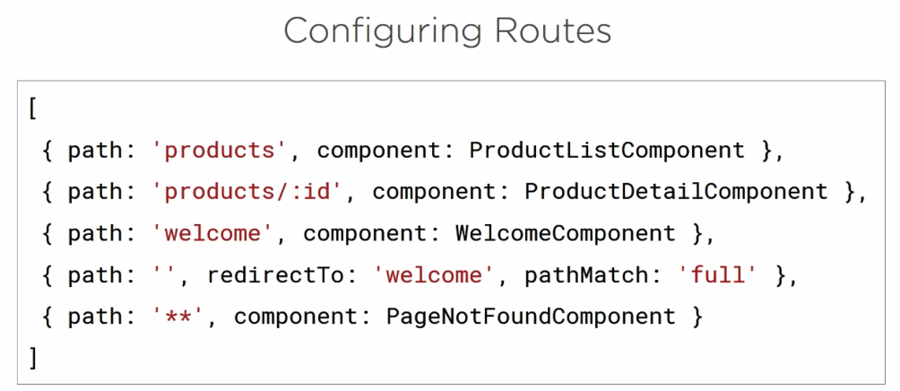

The route must be configured with a list of route definitions. And there list should be inside array of **RouterModule.forRoot([]).** Each definition specifies a route object. Each route requires a path. The path property defines the URL pass segment for the route. When this route is activated, this URL pass segment is appended to the URL of our application. The user can type in or bookmark the resulting URL to return directly to the associated component’s view. In most cases, we specify a component, which is the component associated with the route. It is this component’s template that is displayed when the route is activated. In the examples.

The **1st** route simply maps a specific URL pass segment to a specific component. So, this URL displays the template from the ProductListComponent.

The “**:id”** in the **2nd** route represents a route parameter. The product detail page displays the details for 1 product for that particular id. The ProductDetailComponent reads the id from this pass segment and displays the defined product. We can define any number of parameters here separated with /.

The **4th** route redirect here translates the empty route to desire default pass segment, in this example, the welcome route. A redirect route requires a path match property to tell the route how to match the URL pass segment to the path of a route. We only want this default route when the entire client-side portion of the path is empty, so we set the pathMatch the full.

The * in the **5th** route denote a wildcard path. A few things a note here. There are no leading slashes / in our pass segments, and **the order of the routes in this array matters**. The route uses a first match wins strategy when matching the routes. This means that more specific routes should always be before less specific routes such as the wildcard route.

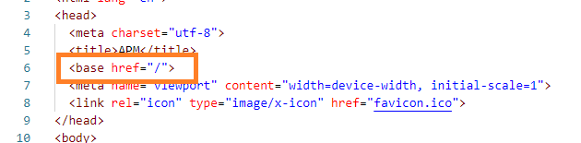

Routing is to define a base element in the head tag of the index.html file. Notice that angular CLI already did that for us here. This element tells the router how to compose the navigation URLs. Since the app folder is the application route, we’ll set the href for the base tag to /. Now we are ready to configure the route definitions.

**Navigating the Application Routes**

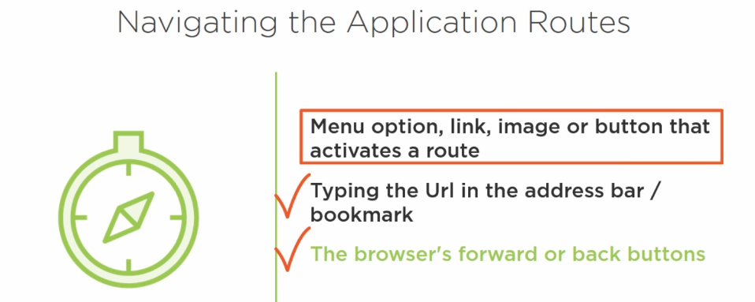

With routing, the user can navigate with routing, the user can navigate through the application in several ways. The user can click a menu option, link, image or button that activates or navigates to a route. The user can type the associated URL segment in the address bar after the application URL, or use a bookmark to that URL, or the user can click the browser’s forward or back button. The route configuration handles the URLs so the last technique will just work. We need to handle the first technique by typing routes to the user actions.

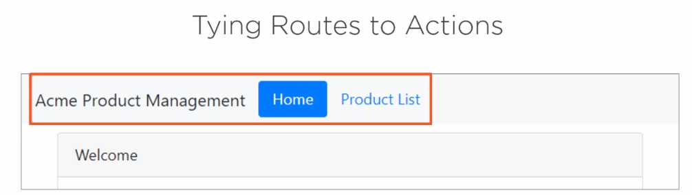

We need to decide how we will show the routing options to the user. We could display a navigation pane with links, we can provide a toolbar or images or we can build a navigation menu like above one.

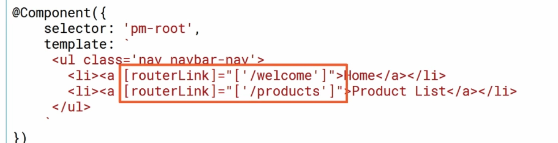

We define the menu as part of this component’s template. We then need to tie a route to each menu option. We do that using a routerLink directive. the routerLink is an attribute directive, so we add it to an element such as the anchor tag here, and we enclose it in square brackets. We bind it to a template expression that return a link parameters array.

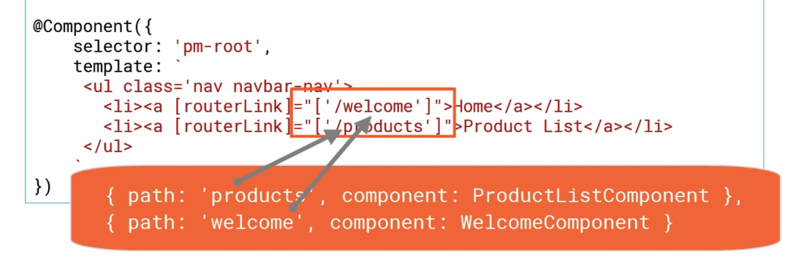

The first element of this array is the string path of a route. Additional element can be added to this array to specify optional route parameters or path parameters. The router uses this array to locate the associated route and build up the appropriate URL based on any provided parameters. When the user selects the option, the associated road is activated. Activating a component route displays that component’s view. Now let’s add a menu and use the router link directive so the user can navigate to the views and our sample application.

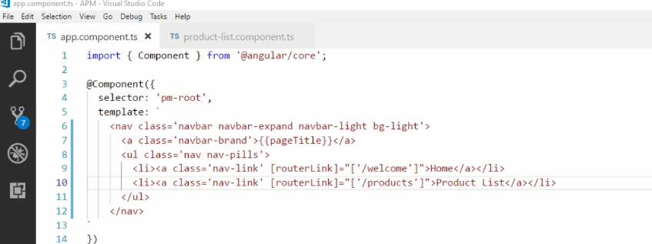

We will add the menu at the root of our application, so we’ll add it to the AppComponent. In the AppComponent template we will replace <pm-products> from app component with above code. And also delete the selector from product-list.component.ts.

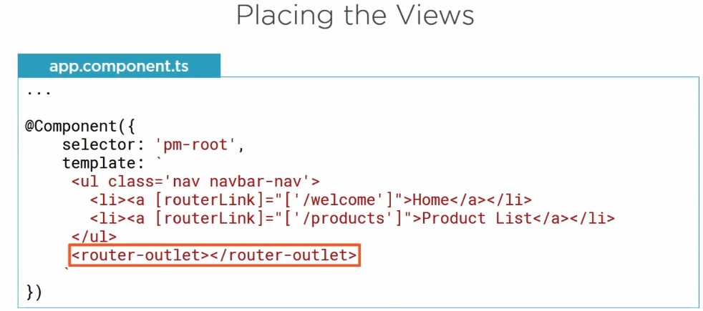

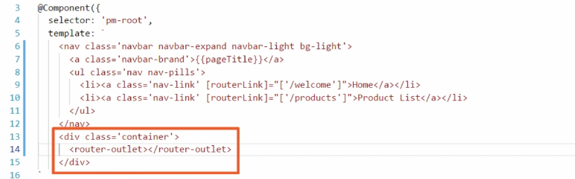

When a route is activated, the associated components view is displayed, but displayed where? How do specify where we want to routed component to display its view? We use the router outlet directive. we place that directive in the host component template. The routed component view then appears in this location.

**To route or to nest, that is the question.**

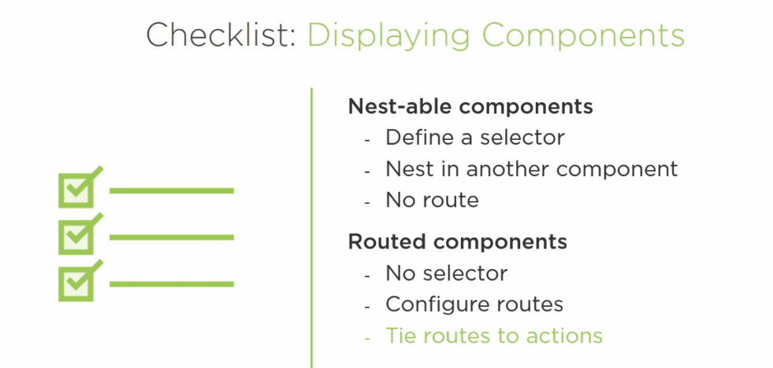

To route or to nest. When creating components, we need to think about how they will be displayed. For component designed to be nested within other components, we need to define a selector as a part of the component decorator. The selector provides the name of the directive, and then we nest the component within another component, using the directive to define where the component template appears. The component does not then need a route. For components design to be displayed as a view within our single application page, the component needs no selector, but we do need to configure routes. We then tie those routes to action. An action activates a route to display the view.

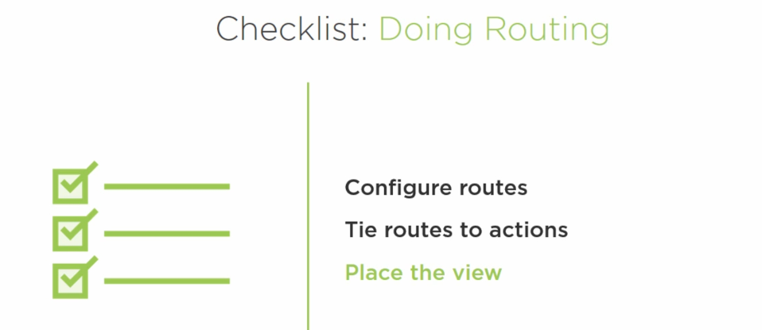

If we want to do routing in our application, we need to configure route definitions, tie routes to actions, and place the view. Begin with configure the routes by defining the base element in the index.html file.

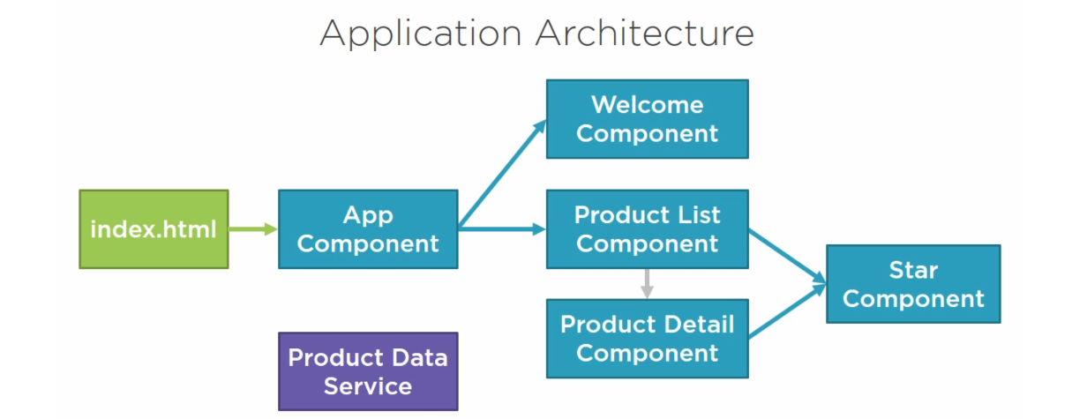

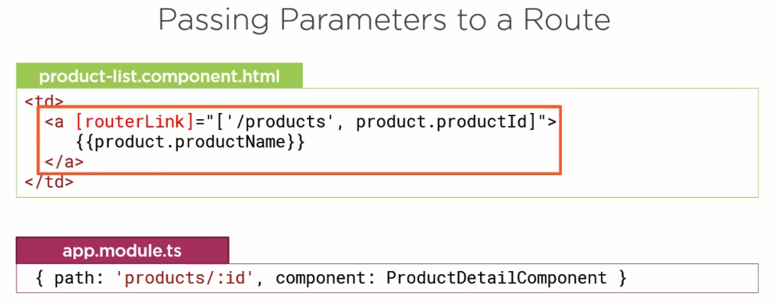

We sometimes need to pass parameters to a to a route. For example, to navigate to the product detail view. We need to define which product details to display. The first step to passing parameters to a route is to configure the route with parameters. We have already done for product detail component. Here we define **/:id.** If multiple parameters are needed, we’d repeat this with another **/: and placeholder.** With the route definition in place, we can decide where we want the user to activate the route. Will we add a menu option or a data link? It is there we set the router link and pass in the required parameter. In the product list component template, we display a table of product. Each table row contains the product name so we add a router link to this anchor tag and assign to the link parameter array. The first element of the array is the string path of the route. The second element of the array is the value for the route parameter. When the router composes the URL, it uses this array element to construct the defined parameter. To display the appropriate product, the product detail component reads this parameter from the URL. It then uses the parameter to retrieve the appropriate product and display it in the view.

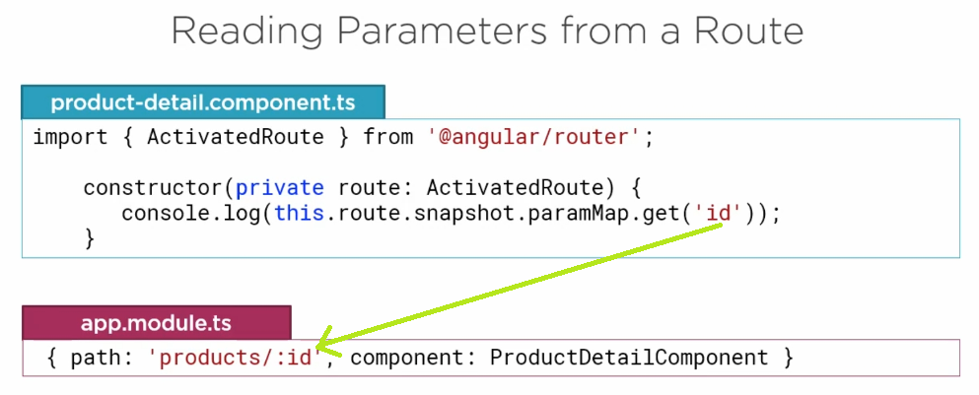

To get the parameter from the URL, we use the **ActivatedRoute** service provided by the router. We want instance of the service so we define it as a dependency in our constructor. Then we use the instance of the **ActivatedRoute** service to get the desired parameter. There are two different ways to get the parameter. We could use a snapshot or we could use an observable. Use the snapshot approach if you only need to get the initial value of the parameter. In our example, the user is always returned to the list page before navigating to another product so the snapshot approach would be sufficient. If you expect the parameter to change without leaving the page, use an observable. For example, if we had a next button on the product detail page to display the next product, the URL will change to the next product’s id. So, you’d want to use an observable instead. We use the activated routes snapshot method here and access the appropriate parameter from its parameter array.

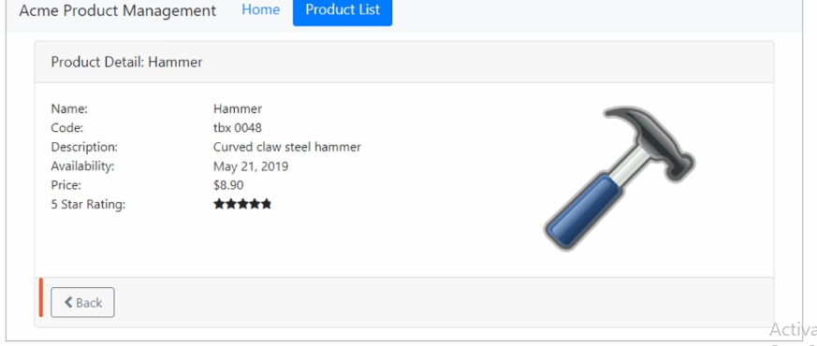

We want to back button to our product detail page that navigate back to the product list page. We could activate this route using the routerLink directive in the component, just like we did with the menu option. But it’s also possible to route with code, so let’s try that out instead.

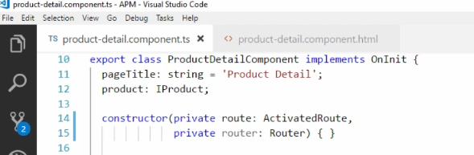

We want the ProductDetailComponent to navigate back to the product list component. We define the router as a dependency by adding another constructor parameter. When this component class is constructed, we’ll get an instance both the ActivatedRoute service and the Router service.

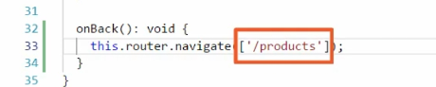

Now we can build a method that navigate a code. Since the purpose of this method is to navigate back, we’ll call it back. It doesn’t return anything, so we’ll set its return type to void. in this method, we use the this.router instance and call the navigate method. We pass it a link parameters array. In this example, we want to navigate back to the productListComponent, and we don’t need any parameters. We just define the route path, which is products.

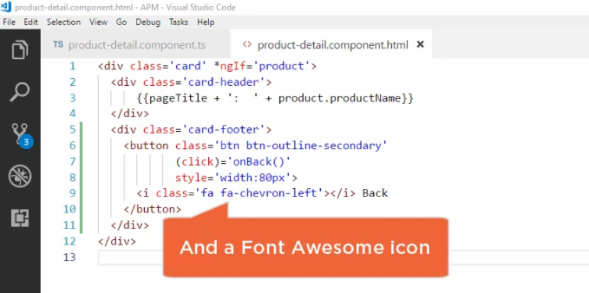

In the product detail template, we’ll add a button. We again use the twitter bootstrap style classes to give the button some style. We use event binding to bind the click event of the button to the onBack() method we define in the class.

